The vProtector Cookbook - Version 1.1
Researched and Written by Aaron Janssen, VSS Monitoring
February 19th, 2013

Preface and Overview

This document focuses on configuration examples for VSS Monitoring’s vProtector product line. All information is confidential, a signed NDA is required to discuss with partners, re-sellers or customers.
Currently there are 7 chapters, totaling 163 pages, please feel free to add any input! This is a preliminary rough draft, based primarily on screen captures that still requires extensive editing for content. All information presented is a best effort of a combination of email threads, SE trainings, data on \\blue.internal.vss, the SE Wiki and various sources such as the VSS Partner Portal or the VSS Knowledgebase. Credit needs to be given to Ollie Sheridan who originally created the Filtering Cookbook and to all of the SEs and others who have contributed to it the along the way. The Filtering Cookbook will be used as the inspiration for this work; please do not take this document as gospel, your mileage will vary widely depending on network speed/traffic conditions, tool combinations and the amount of tuning you do to the solution.
For comprehensive testing and configuration assistance please consult the VSS Corporate SE Team or the VSS Validation Laboratory.

Silicon Valley Bank

Overview: 3 Data Centers (Salt Lake City, San Jose, London). 5 vProtector 612s were proposed, all copper 1G links and tools.
Requirements: Security in Series required for all locations, different tools at different locations.
Location: Data Center 1 (Salt Lake City).
- 2 Internet WAN Links (Active and Passive)
  - Tools
    - McAfee IPS (In-line), WAF (In-line)
- 2 eCommerce WAN Links (Active and Passive)
  - Tools
    - McAfee IPS (In-Line), FireEye (Inline) 2 ports requiring LB, Vontu (Inline)
Location: Data Center 2 (San Jose).
- 2 Internet WAN Links (Active and Passive)
  - Tools
    - McAfee IPS (In-line), WAF (In-line)
- 2 eCommerce WAN Links (Active and Passive)
  - Tools
    - McAfee IPS (In-Line), FireEye (Inline) 2 ports requiring LB, Vontu (Inline)
Location: Data Center 3 (London).
- 2 Internet WAN Links (Active and Passive)
  - Tools
    - McAfee IPS (In-line), WAF (In-line)

Lightspeed
Lightspeed 2020 Trigger Functionality
4 Lightspeed Rocket 1900 Appliance 1 (Health Check Failure)
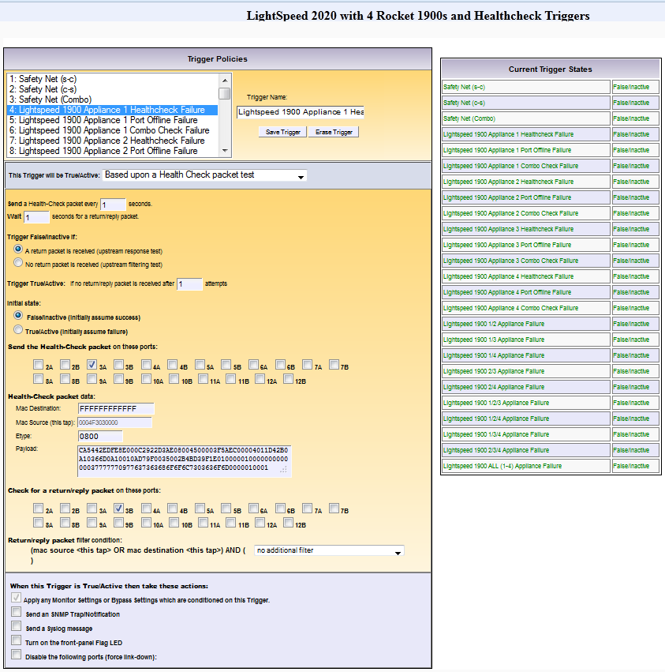

5 Lightspeed Rocket 1900 Appliance 1 (Port Offline Failure)
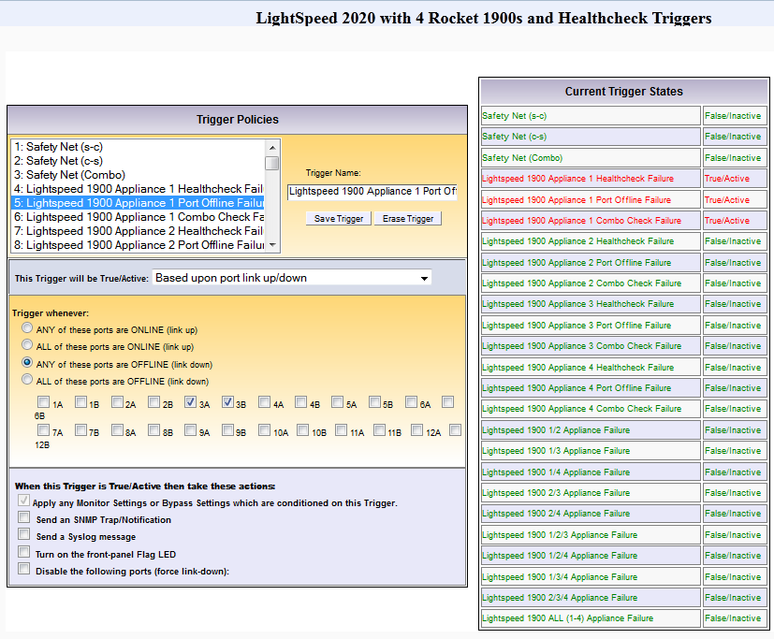

6 Lightspeed Rocket 1900 Appliance 1 (Combo Check Failure)
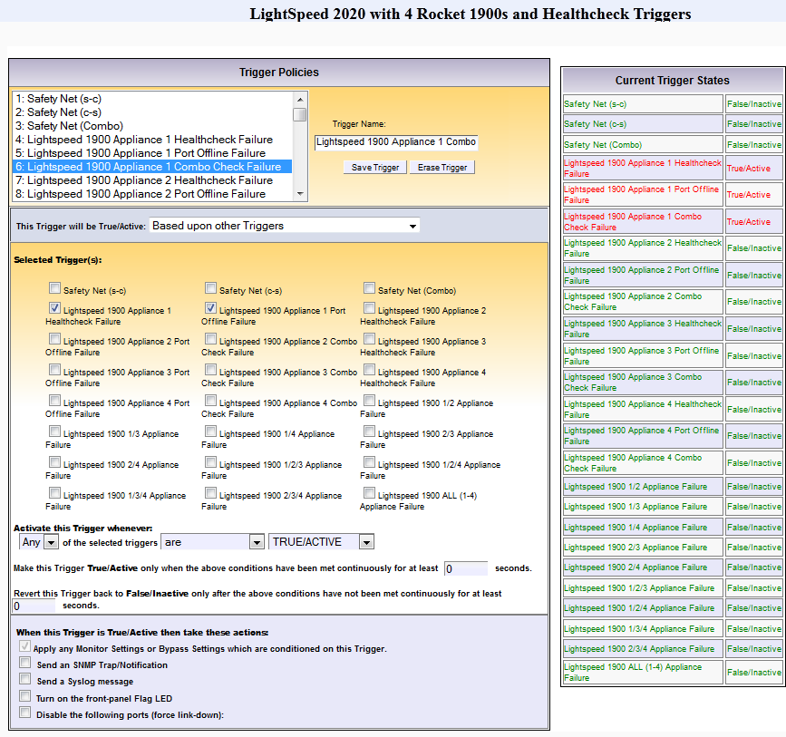

7 Lightspeed Rocket 1900 Appliance 2 (Health Check Failure)
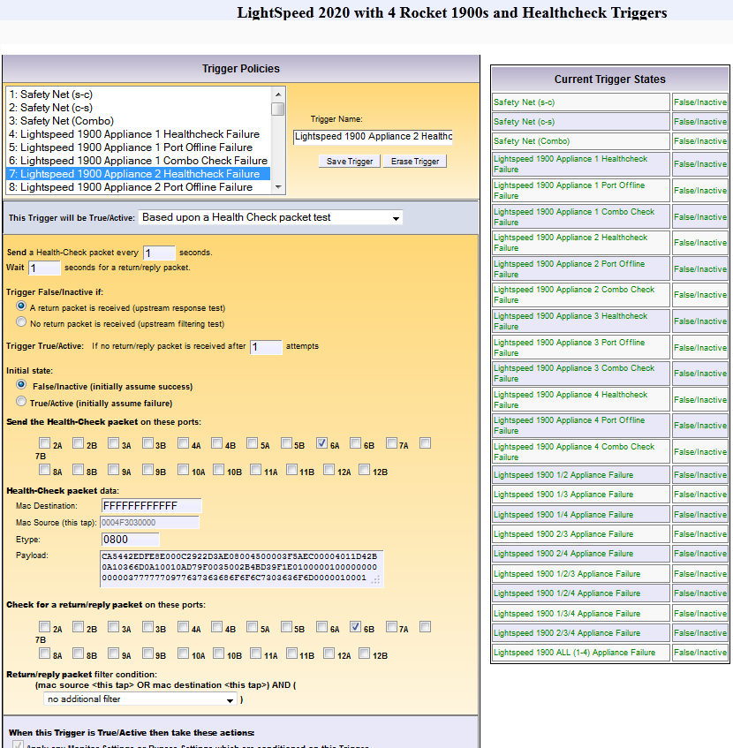

8 Lightspeed Rocket 1900 Appliance 2 (Port Offline Failure)
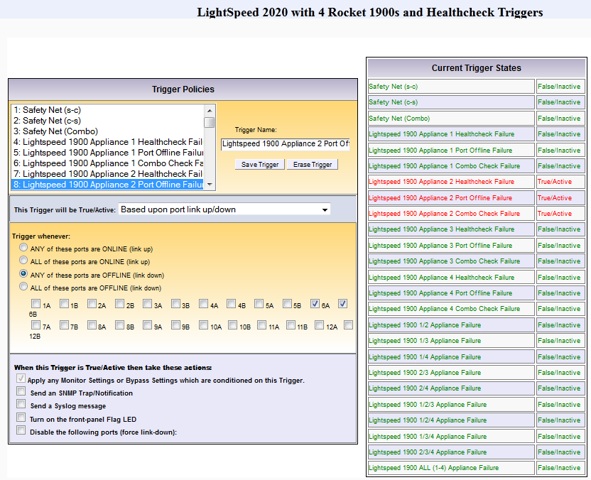

9 Lightspeed Rocket 1900 Appliance 2 (Combo Check Failure)
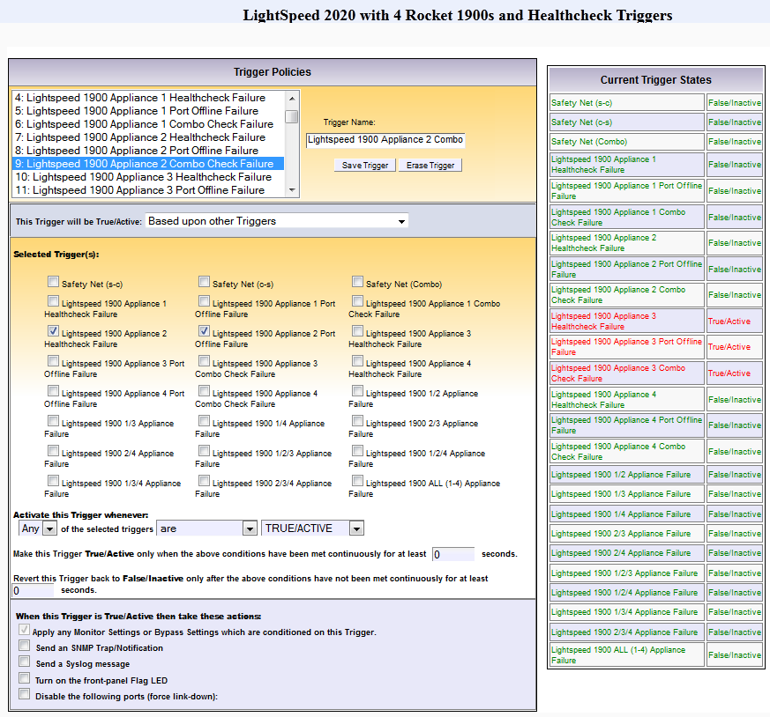

10 Lightspeed Rocket 1900 Appliance 3 (Health Check Failure)
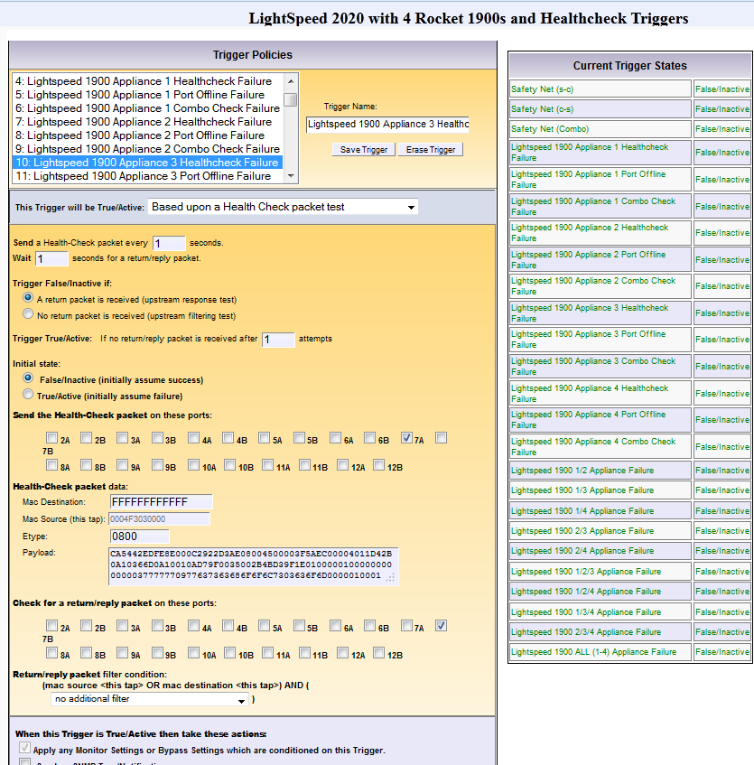

11 Lightspeed Rocket 1900 Appliance 3 (Port Offline Failure)
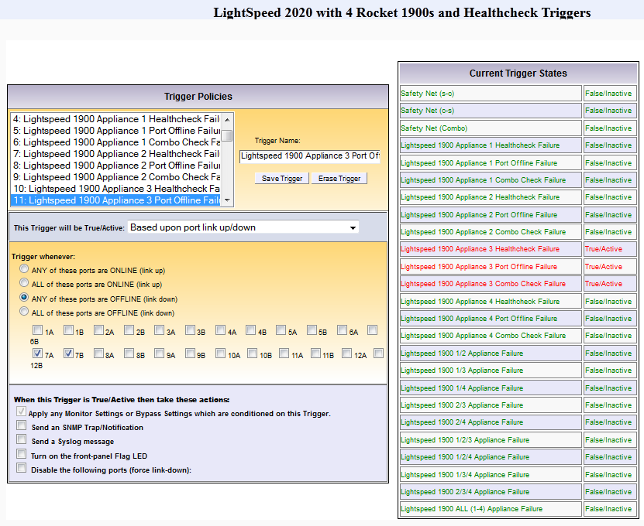

12 Lightspeed Rocket 1900 Appliance 3 (Combo Check Failure)
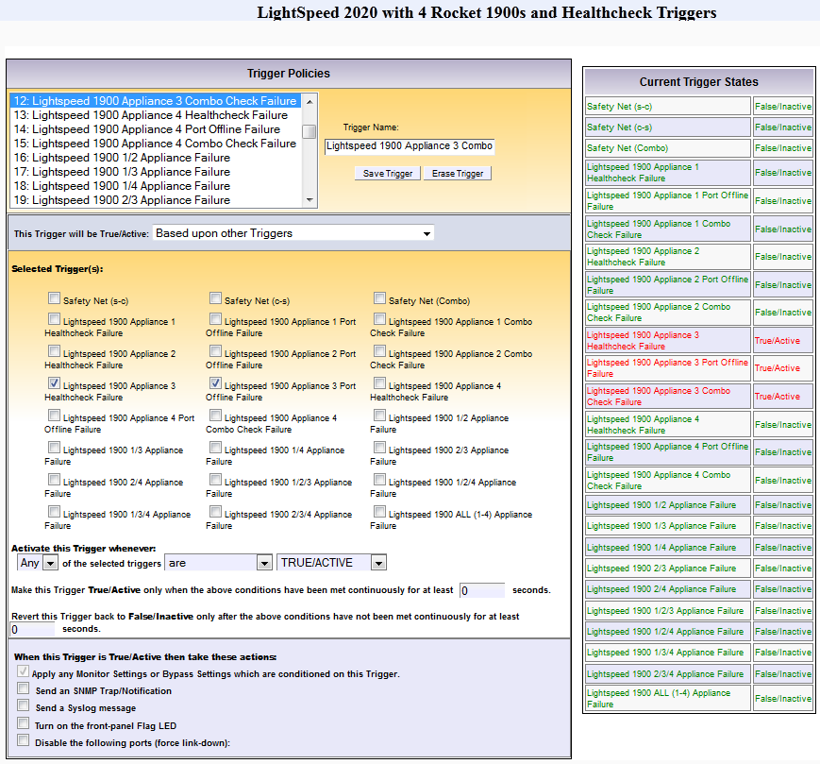

13 Lightspeed Rocket 1900 Appliance 4 (Health Check Failure)
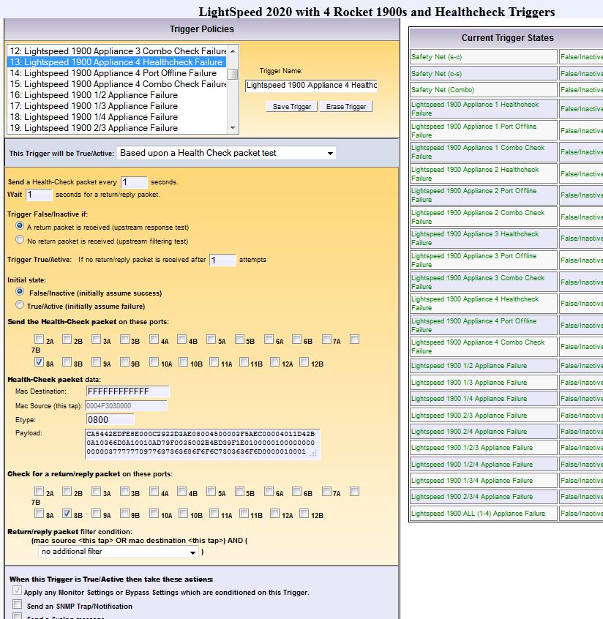

14 Lightspeed Rocket 1900 Appliance 4 (Port Down Failure)
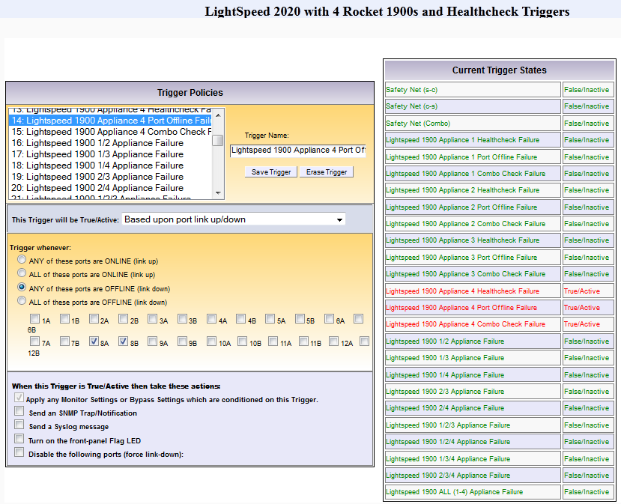

15 Lightspeed Rocket 1900 Appliance 4 (Combo Check Failure)
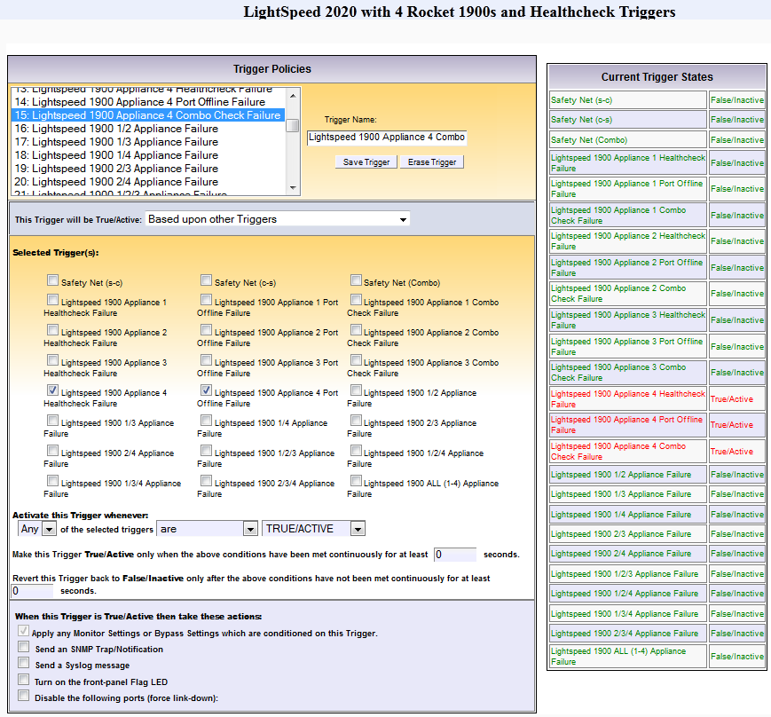

16 Lightspeed Rocket 1900 Appliance 1 and 2 Failure
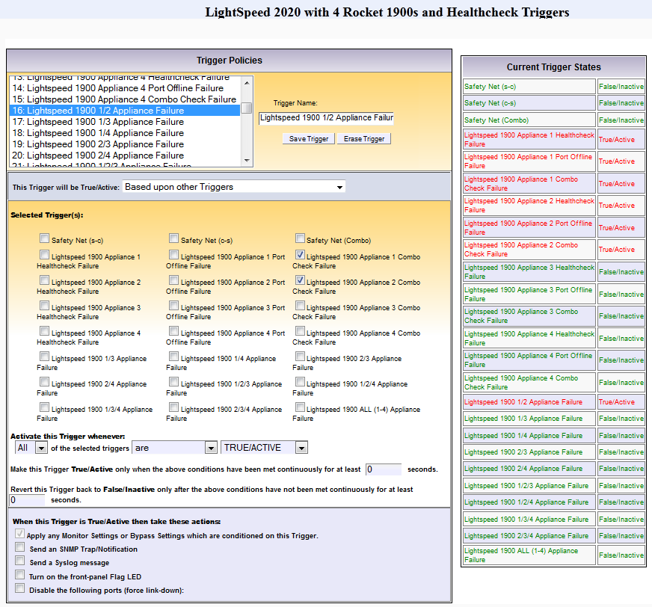

17 Lightspeed Rocket 1900 Appliance 1 and 3 Failure
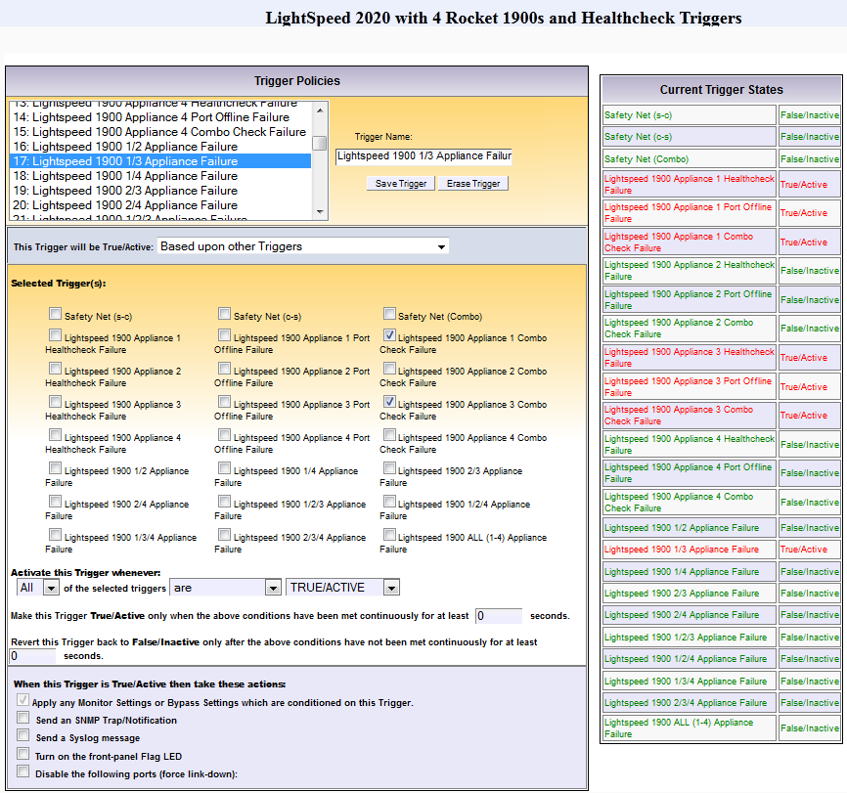

18 Lightspeed Rocket 1900 Appliance 1 and 4 Failure
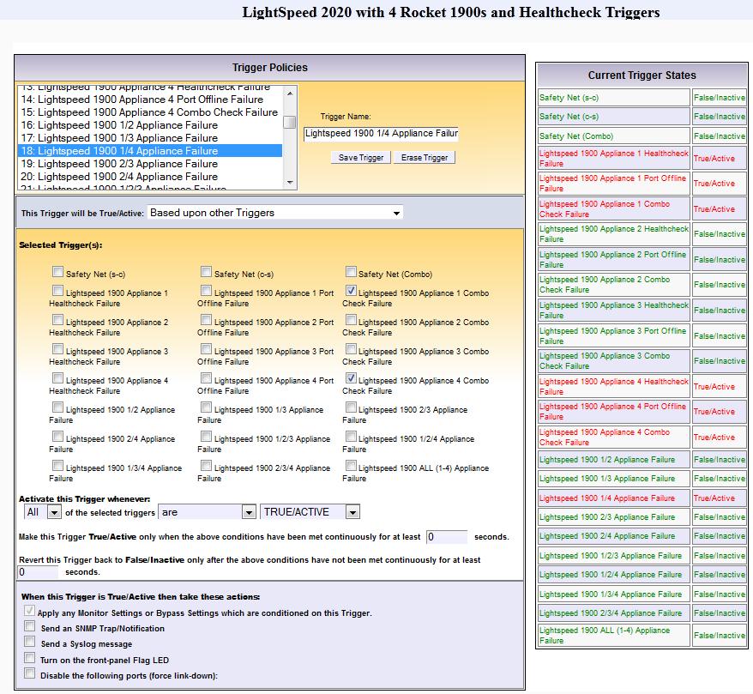

19 Lightspeed Rocket 1900 Appliance 2 and 3 Failure
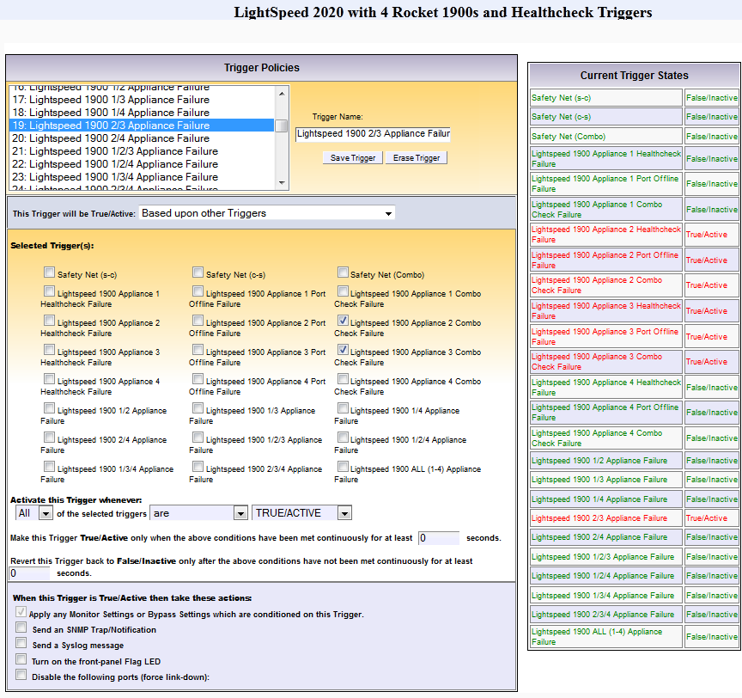

20 Lightspeed Rocket 1900 Appliance 2 and 4 Failure
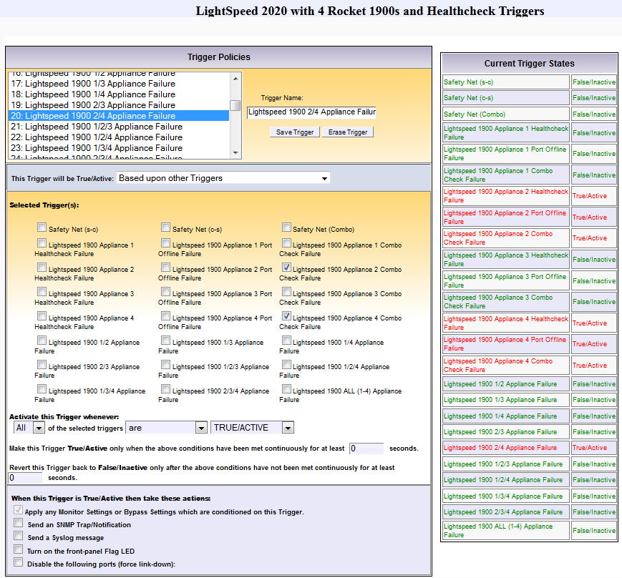

21 Lightspeed Rocket 1900 Appliance 1, 2 and 3 Failure
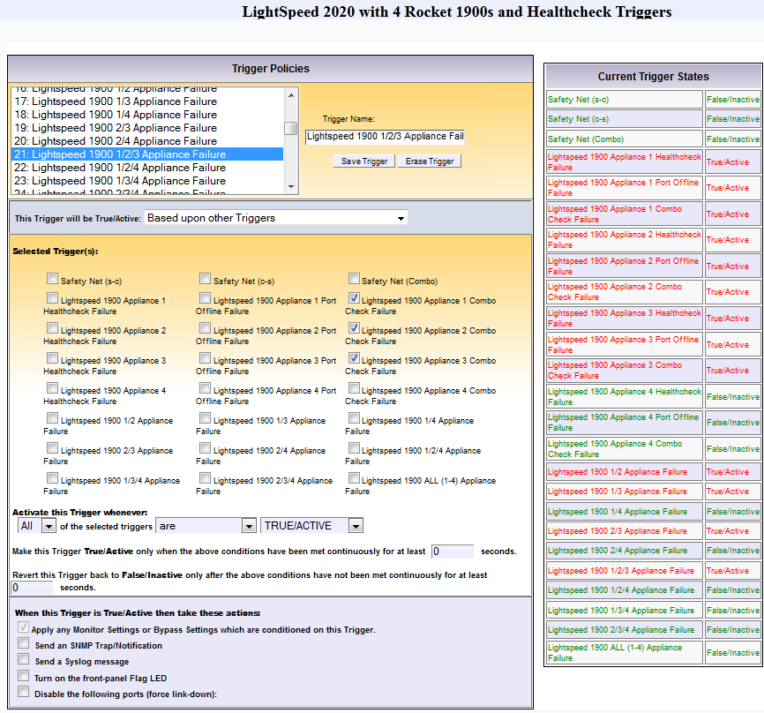

22 Lightspeed Rocket 1900 Appliance 1, 2 and 4 Failure
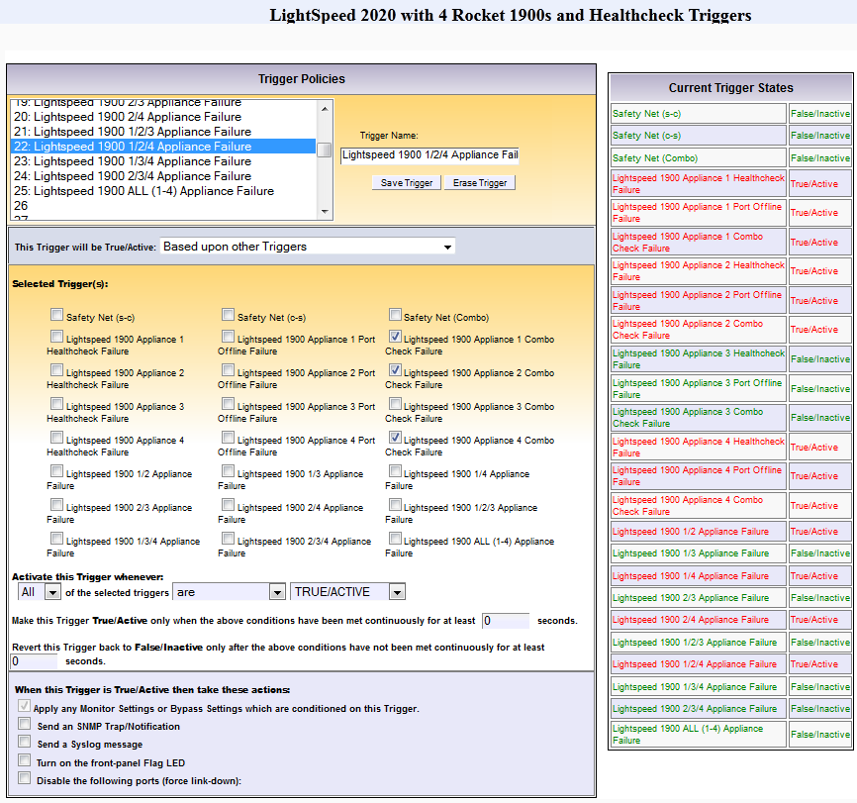

23 Lightspeed Rocket 1900 Appliance 1, 3 and 4 Failure
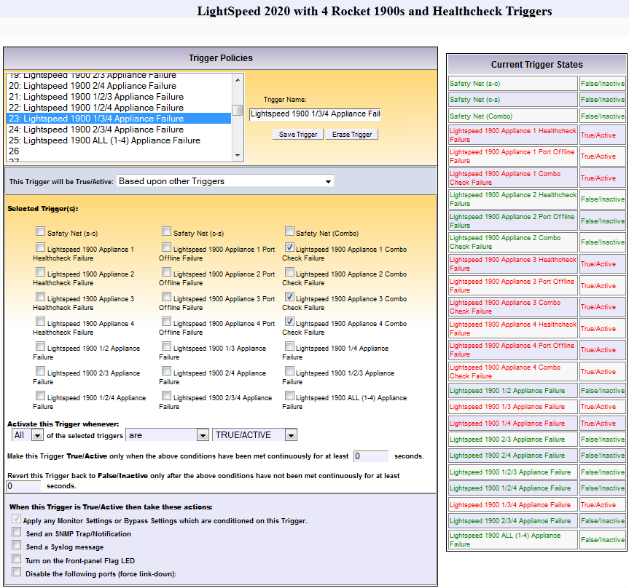

24 Lightspeed Rocket 1900 Appliance 2, 3 and 4 Failure
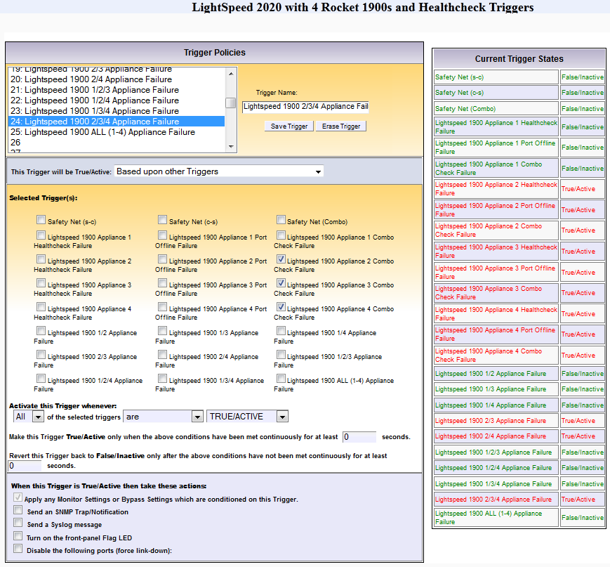

25 Lightspeed Rocket 1900 All Appliance 1, 2, 3 and 4 Failure
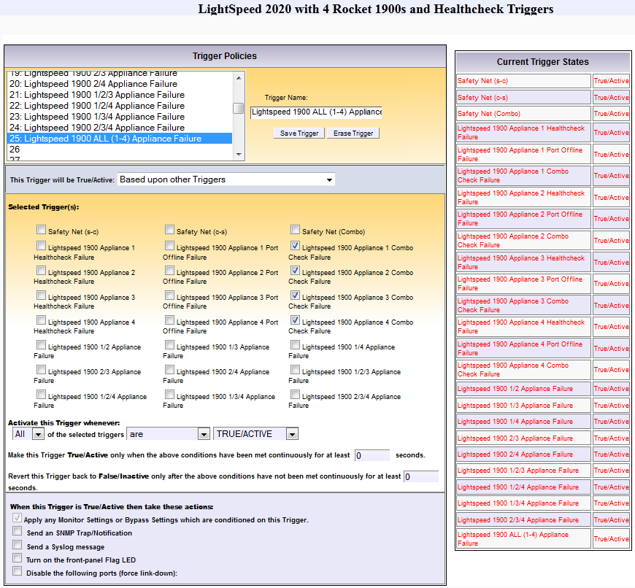

Genentech
The configuration has a password on it: VSS, vss, vss123 did not work.
Application Note
Introduction:
This document has been created to assist Protector 2020 customers and Sales Engineer who wish to deploy security in layer solutions to protect inside and outside threat. The information and examples provided here may be different than your deployment, but should provide the necessary information needed to understand how you might want to configure Protector2020 along with other Security devices inline devices.
This document covers the following Products:
- VSS Protector 2020, Inline Active and Passive inline tool
- FireEye 1300 Series intercept all incoming and outgoing email and Web traffic for malware detection. FireEye inline operational mode can be configured to Block, Monitor or Bypass traffic.
- Blue Coat ProxySG 900 intercepts all Web traffic. Inline operational mode can configured to Block, monitor or bypass traffic.
Deployment Topology:
Figure 1
As shown in Figure 1 above, Cisco 4900 is HSRP Active router. All traffic from inside traverse through Cisco 4900, VSS Protor2020 inline device, load balanced traffic between two FireEye and BlueCoat Proxy SG devices. FireEye are configured to test both monitor and block mode. Bluecoats are configured to intercept unauthorized website access and notify user that their website access violated company’s policy.
Issues and Solution:
- Palo Alto Firewall and Cisco routers are using 10Gig interface whereas BlueCoat and FireEye’s monitor interfaces are 1Gig.
- All traffic destine to internet need to be intercepted by FireEye for malware detections. In future other third party vendor’s security tools will be added in series.
- Only web traffic need to be sent to BlueCoat proxy device without using Cisco’s Web Cache Communication protocol (WCCP) for ease of manageability and troubleshooting.
VSS Protector 2020 is inline Active or Passive monitoring device. It has 24 ports. Each port can be configured as 10Gig or 1Gig interface. Load balance feature can send traffic to eight inline Active or Passive monitoring tools. Packet flow diagrams to address above issues are as shown below in figure 2.
Figure 2.
In above Figure 2, each FireEye inline monitor ports are physically connected to 3A, 3B and 4A, 4B port pairs. All client’s traffic destine to internet load balance between two FireEyes in port 3A and 4A. Load balance criteria are based on client’s source IP (SIP). Protector 2020 hash SIP to track which port client’s request came from. Response traffic load balanced based on destination IP address in 3B and 4B using the same hashing algorithm. 1B port physically connected to port 2A. TCP source or destination port 80 filters applied in port 2A to send only Web traffic to BlueCoat. Non Web traffic will be sent directly to 2B. Same Source IP and destination IP load balancing criteria applied in 5A, 6A and 5B, 6B.
Following use cases executed in this scenario:
- Send 10 clients GET request to one Server. Simple HTTP GET request. Run tcpdump in both FireEyes. Analyze the results of tcpdump. Objective is to check if inline devices are seeing that traffic. Also, to observe traffic is getting load balance
- #tcpdump –ni pether3 –f ‘host x.x.x.x’
- Send 100 Clients GET request to 10 servers. Simple HTTP GET request. Run tcpdump in both FireEye. Analyze the results of tcpdump. Objective is to check load balance.
- Send 10 Clients GET request to 1 server. Each GET is malware pdf download. Objective is to verify FireEye blocking feature.
- Find maximum transaction per sec throughput of FireEye. Couple of GET should be malware. Check if FireEye can catch it.

Deployment
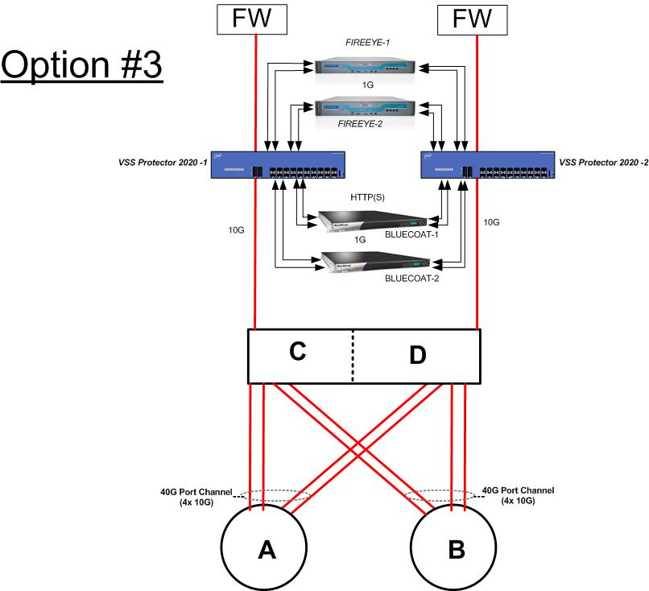

Filter 1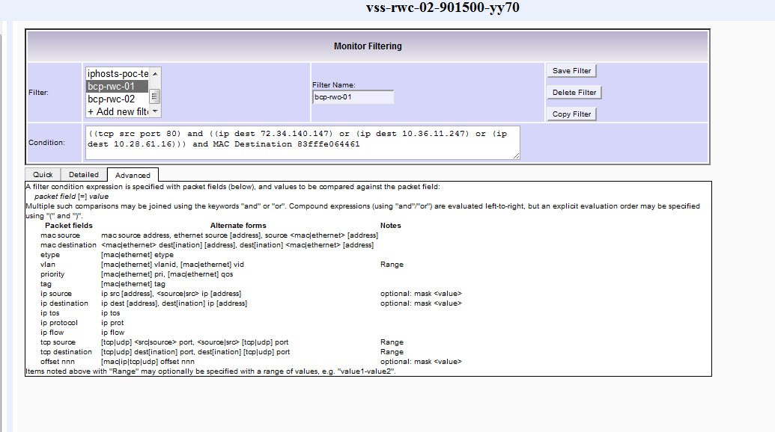Filter 2
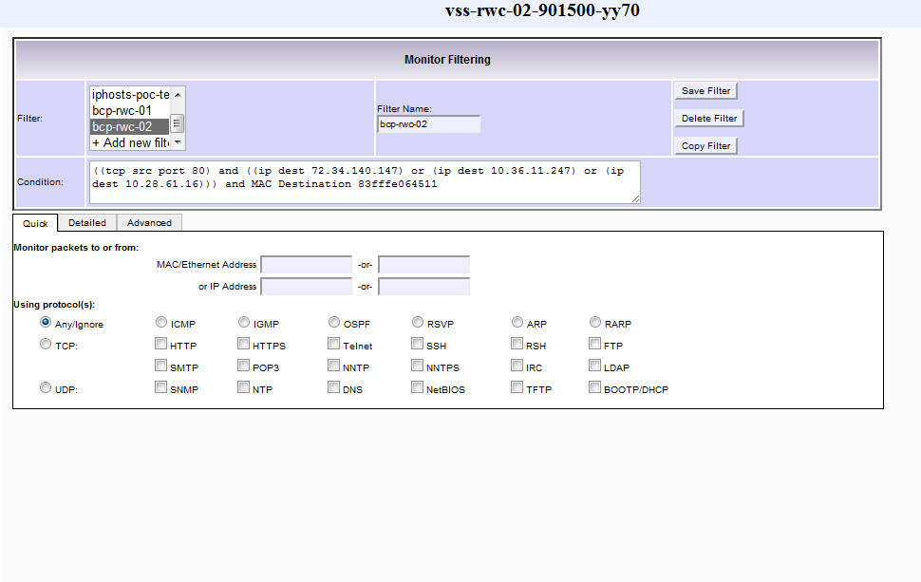
Filter 3
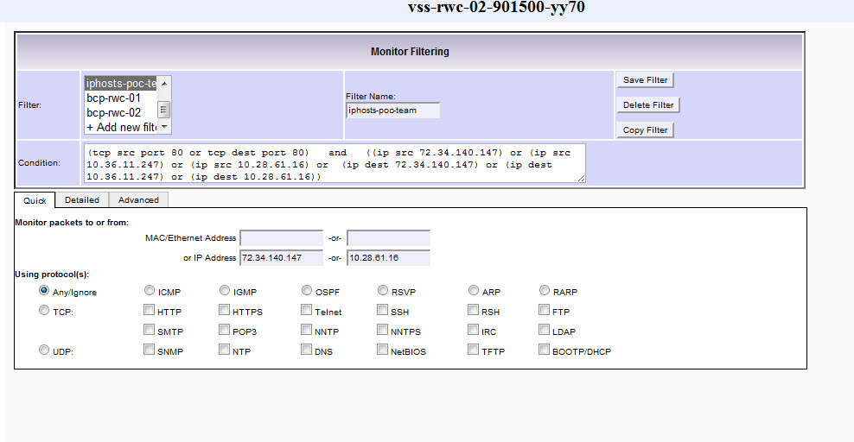
Bypass Settings
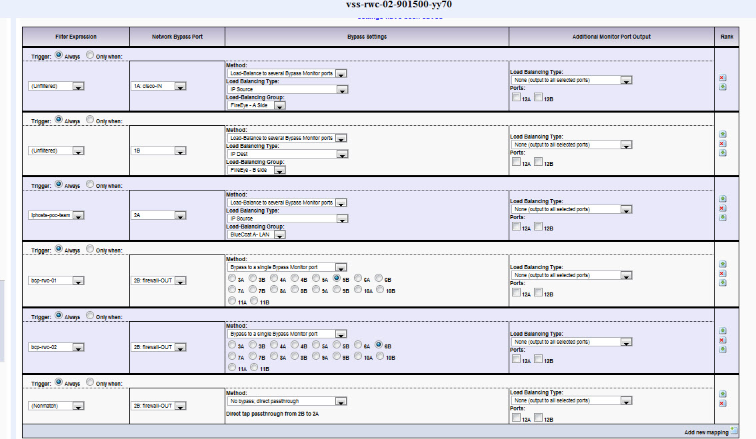
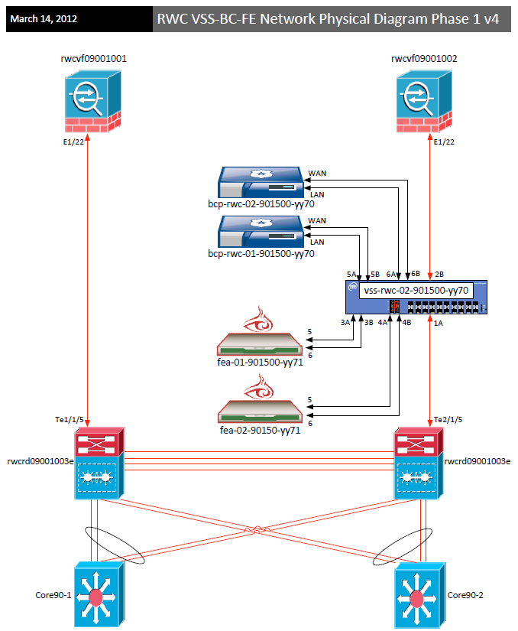
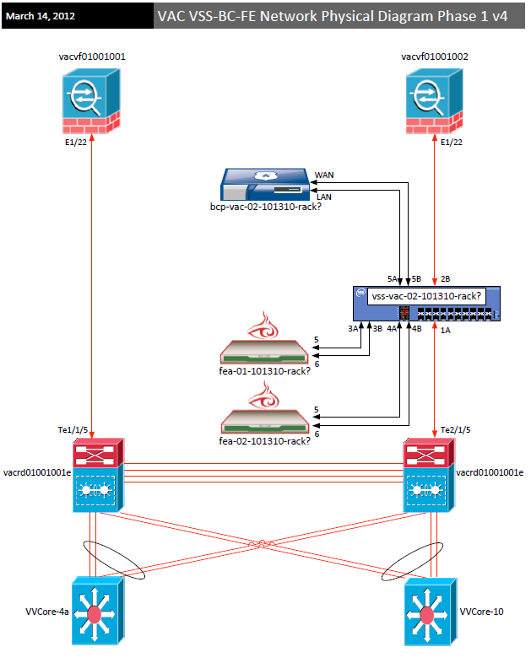

Dominion

Dominion Screen Snapshots
System Status:
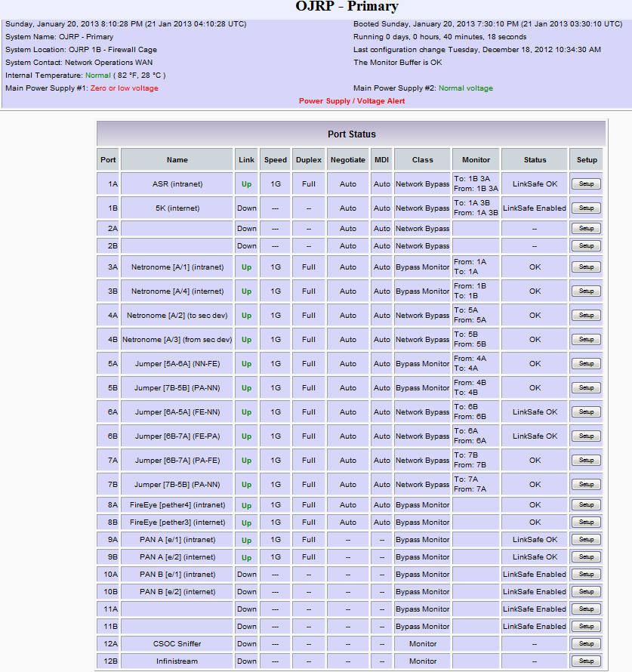

Monitor Filtering:
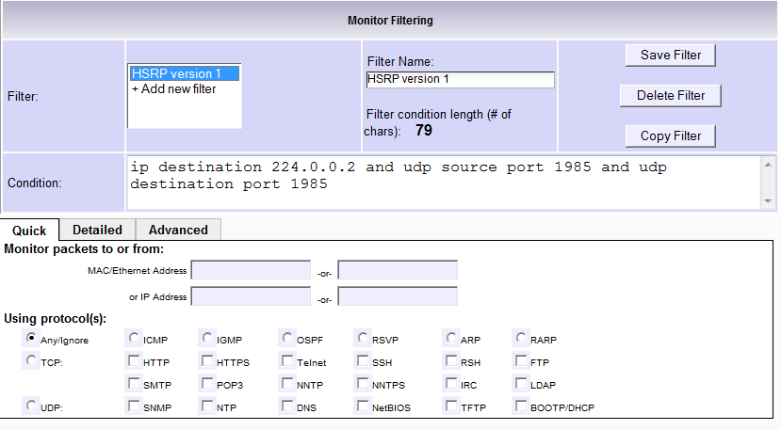

Load Balancing:
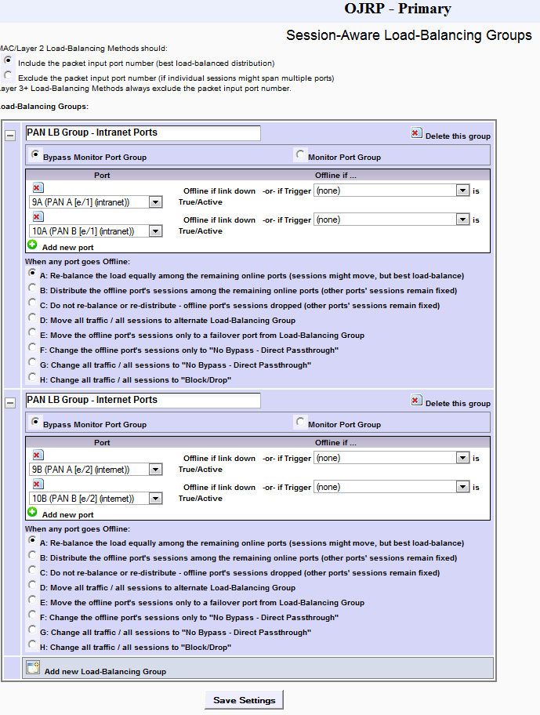
Bypass Monitor I: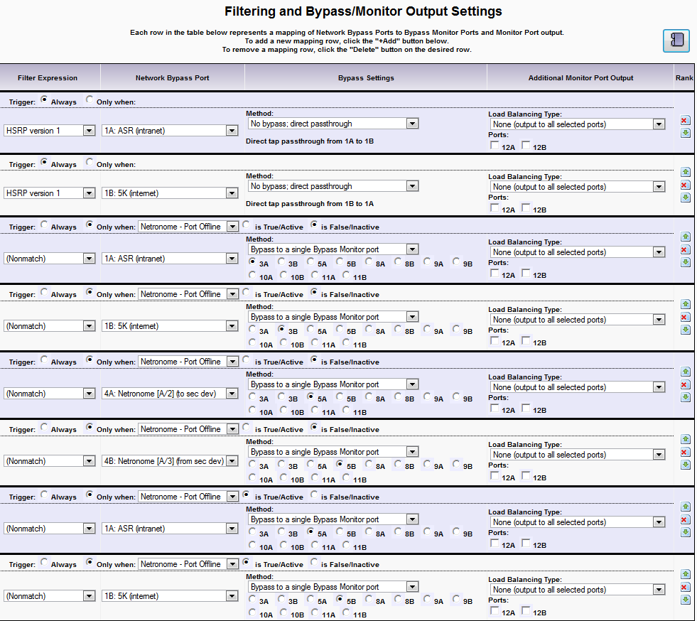

Bypass Monitor II:
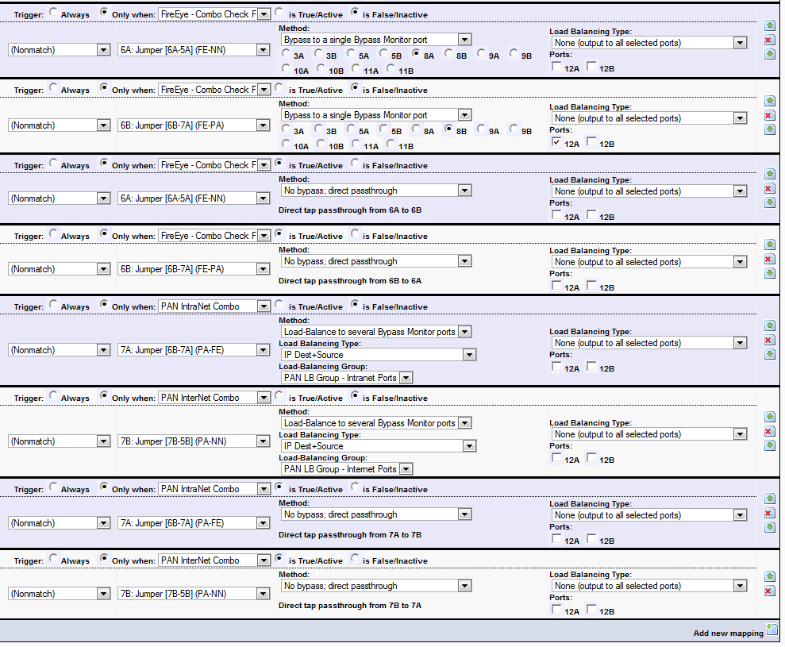

Triggers:
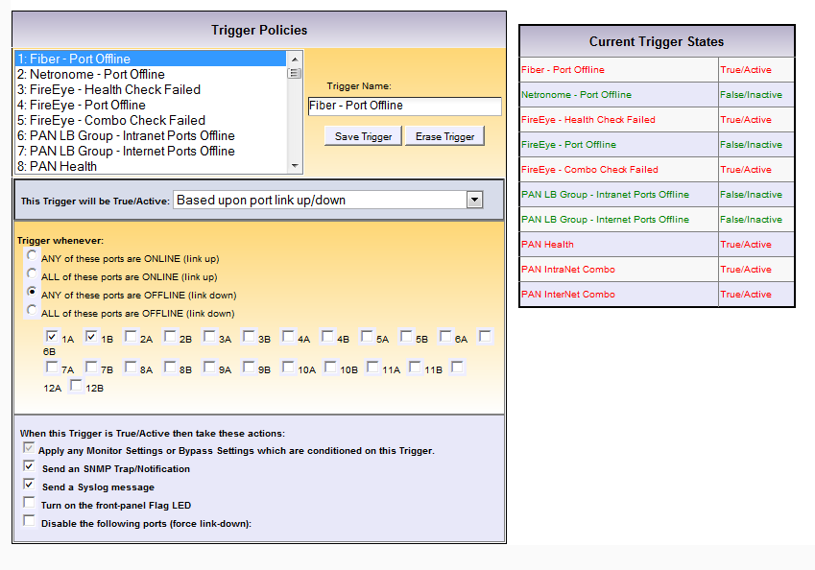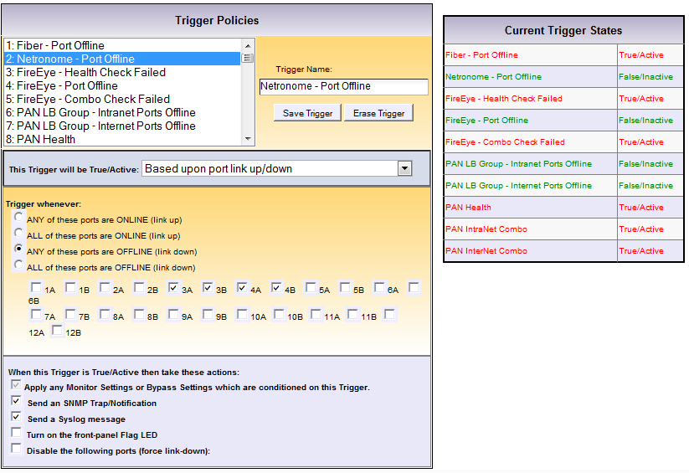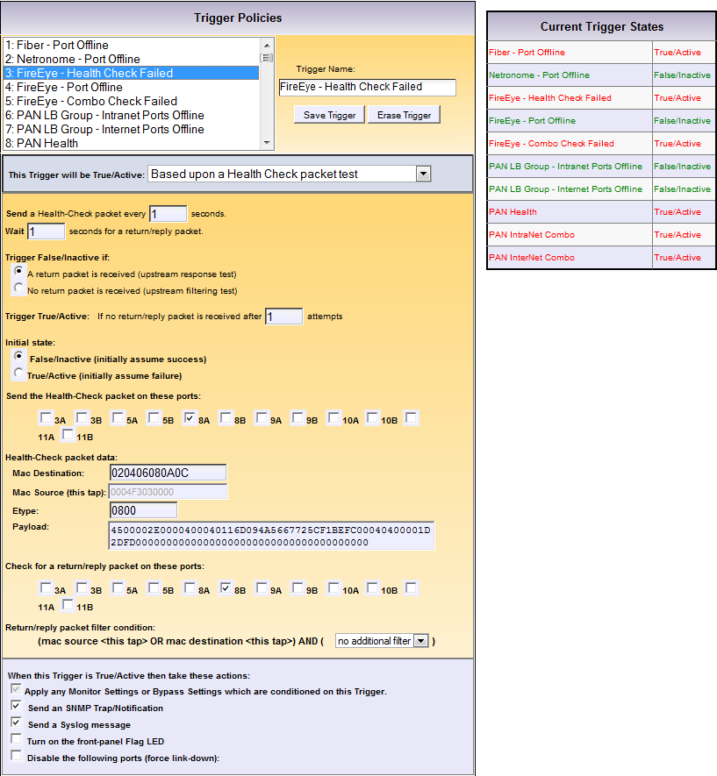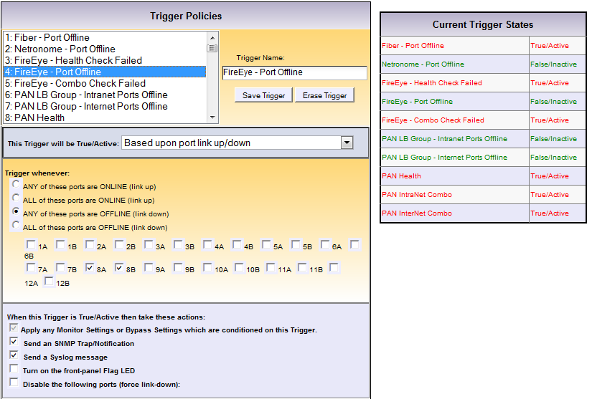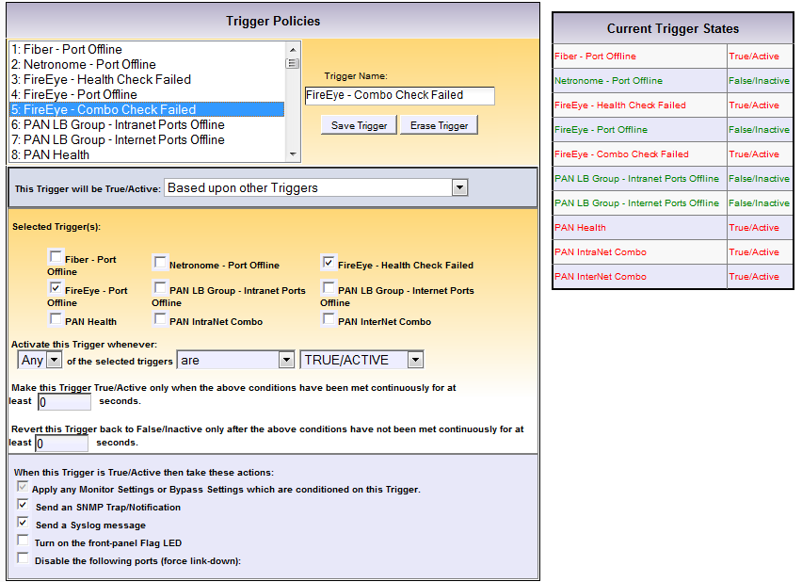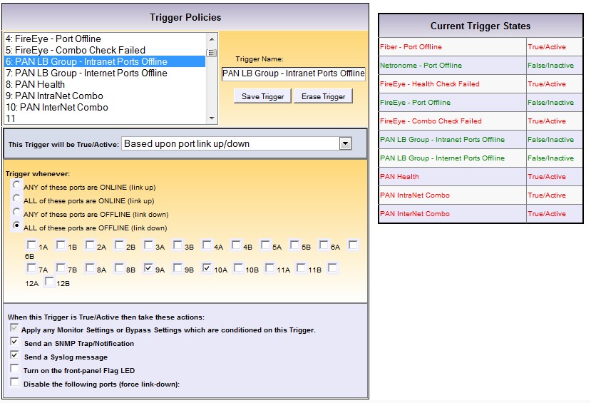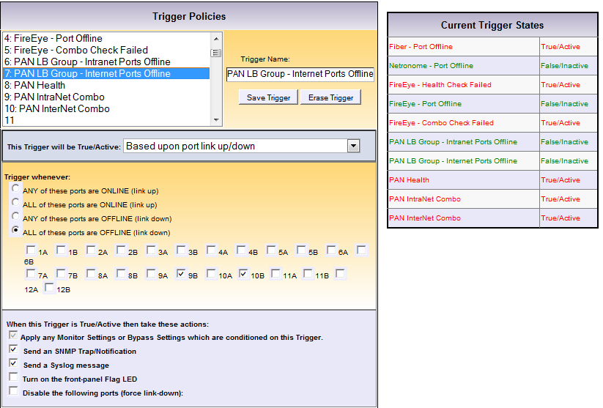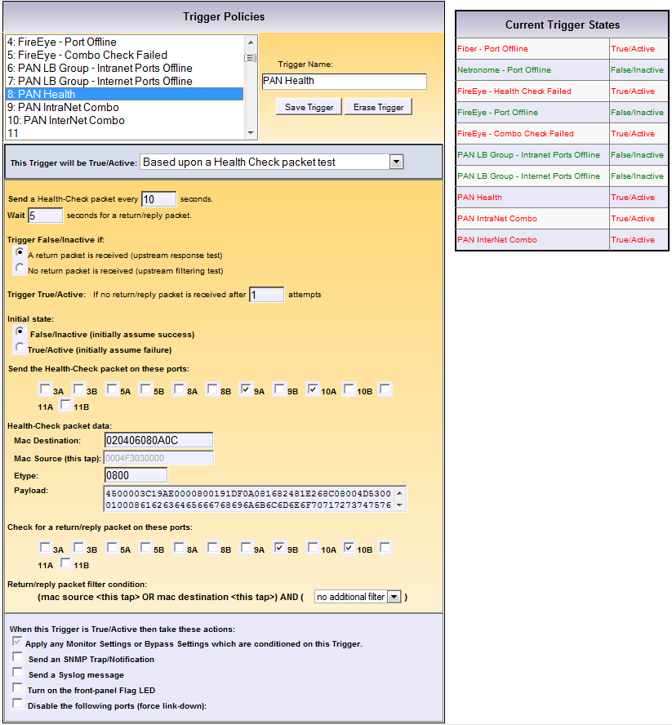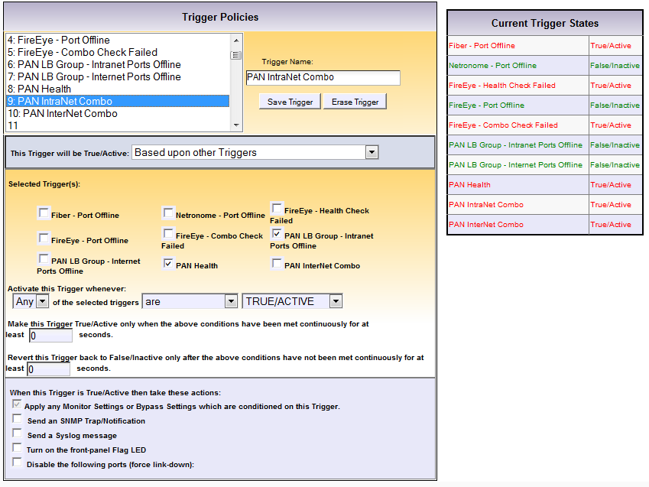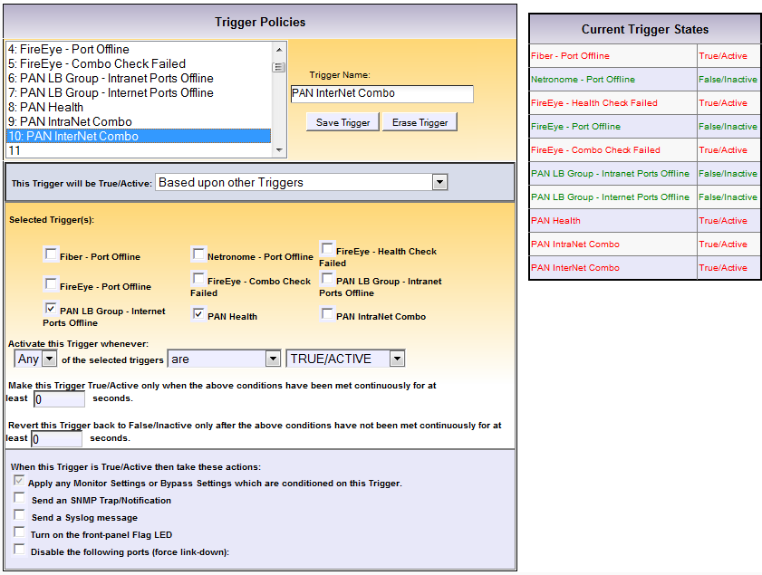
Diagram and Mappings:
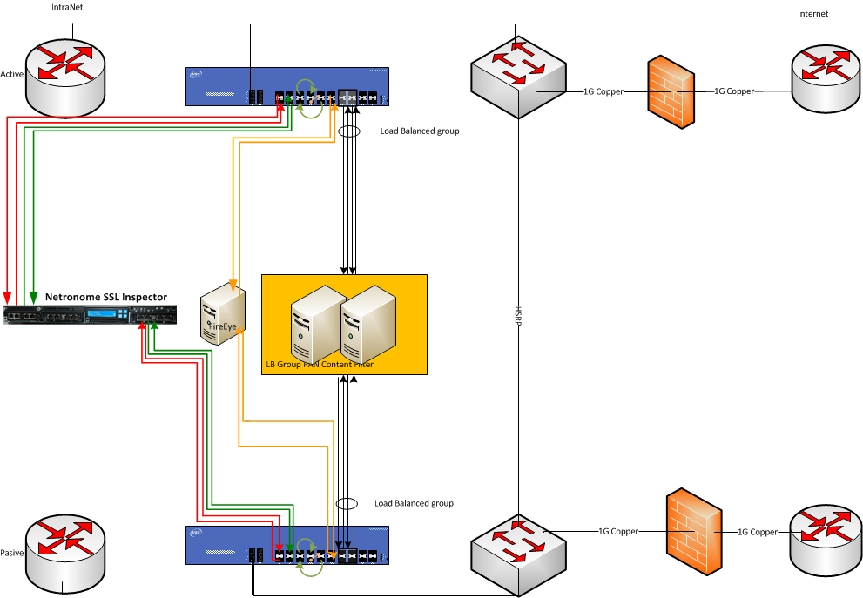
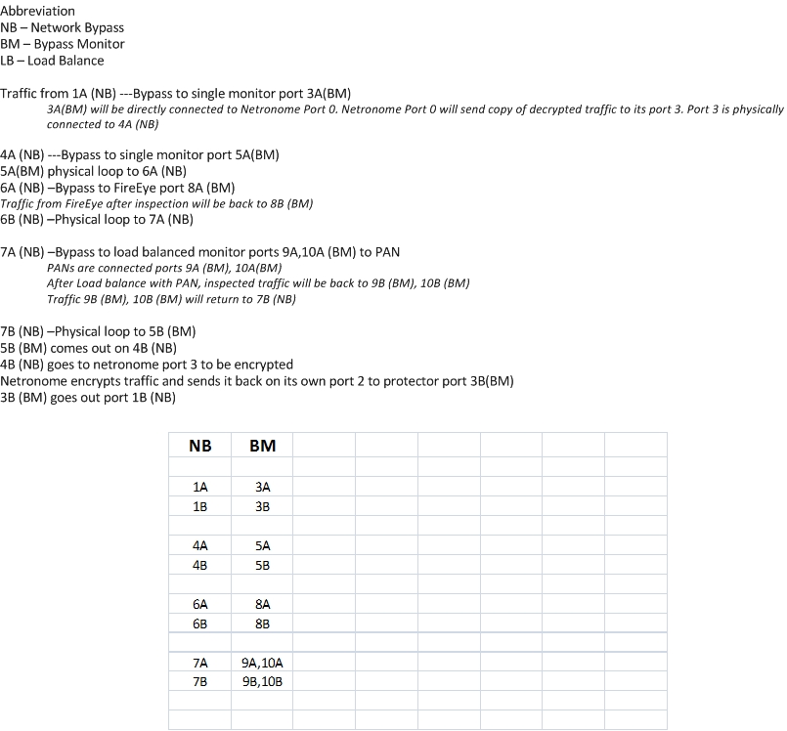

Vodafone NSU Internet

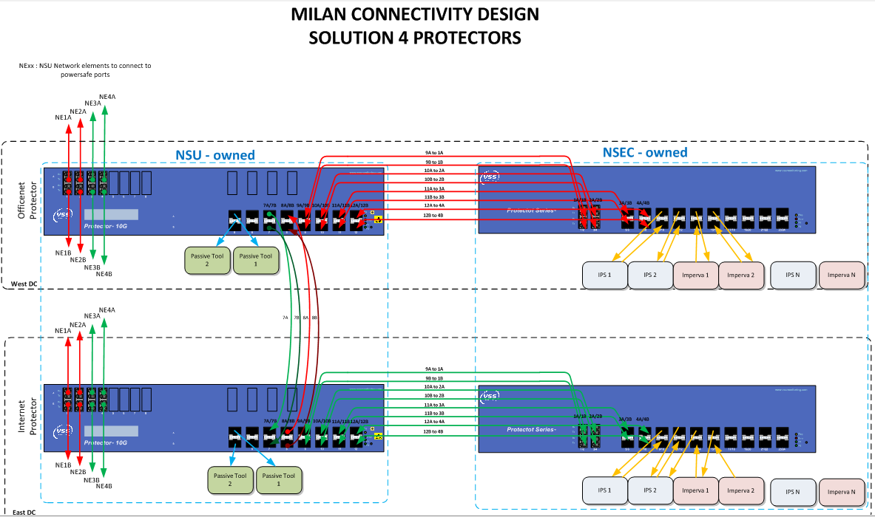
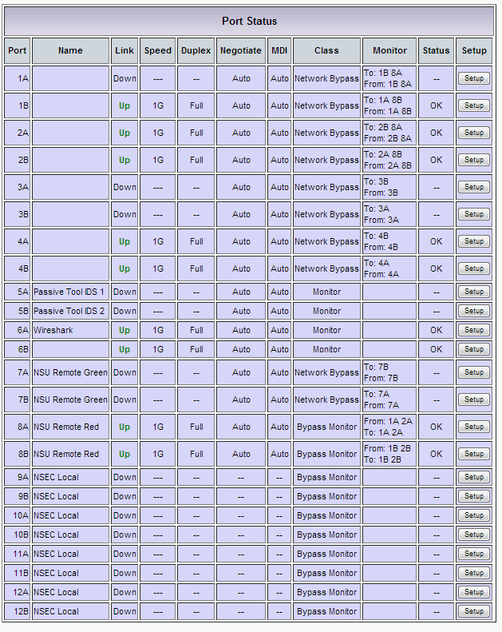

Port setup
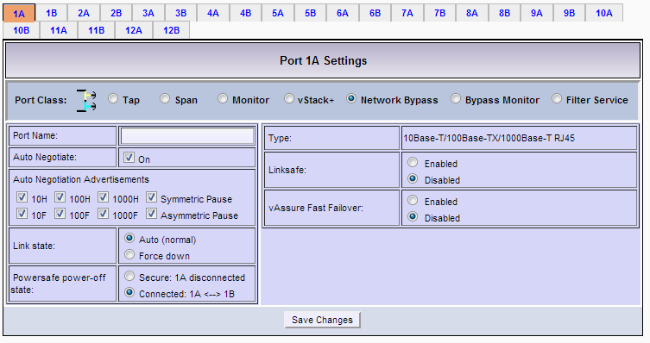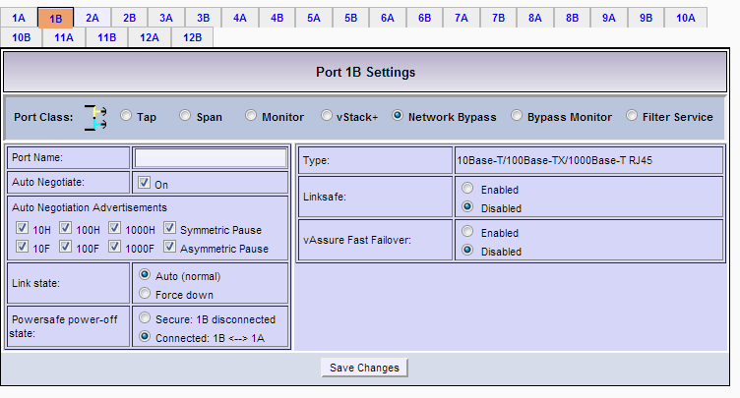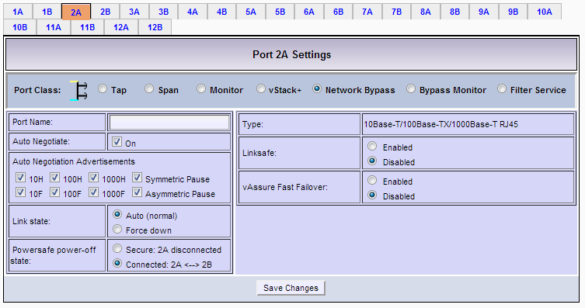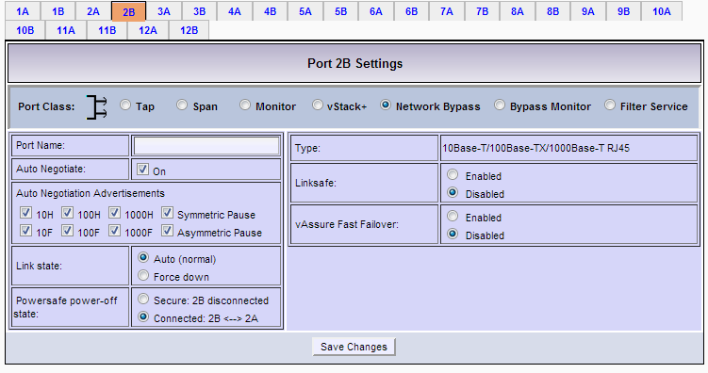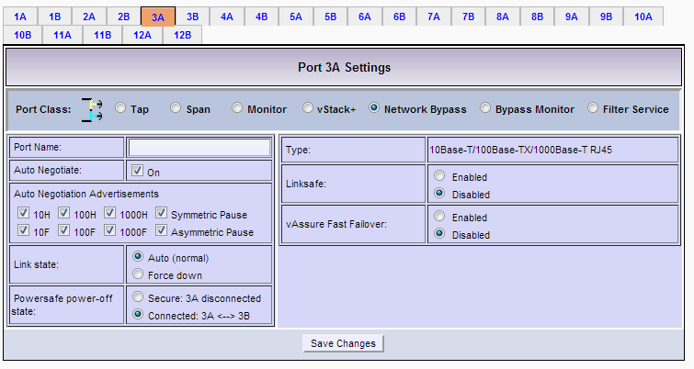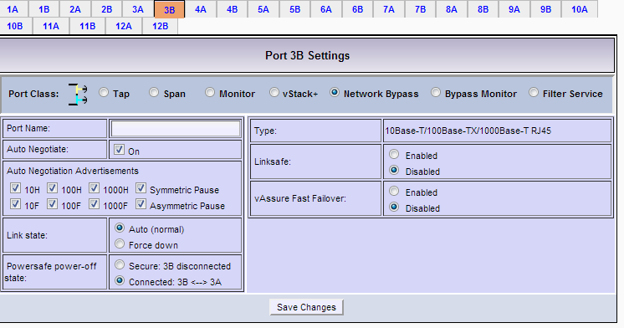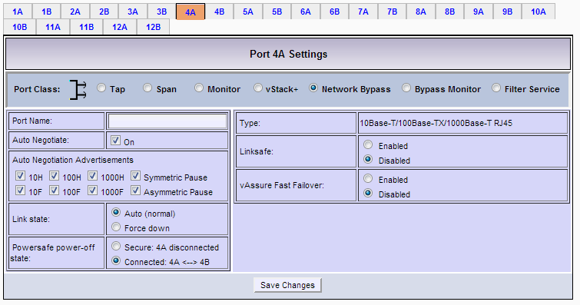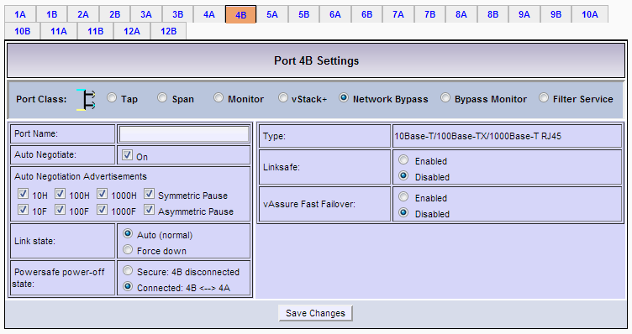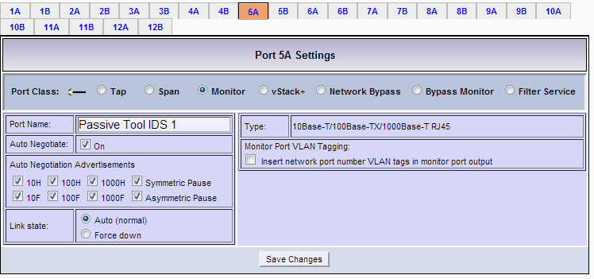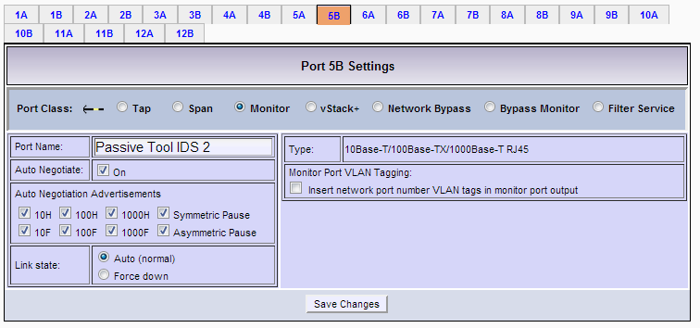
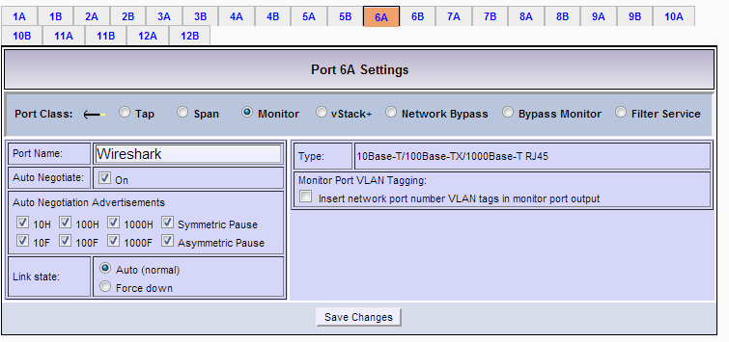
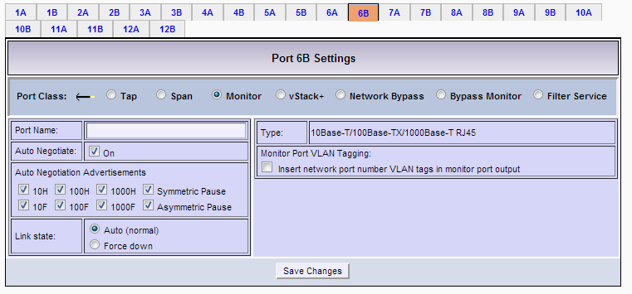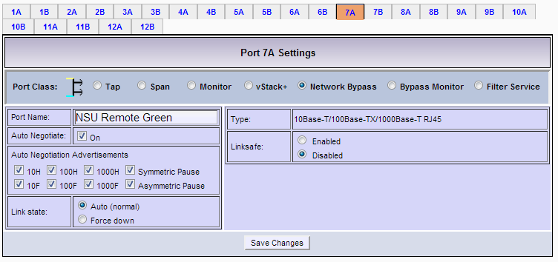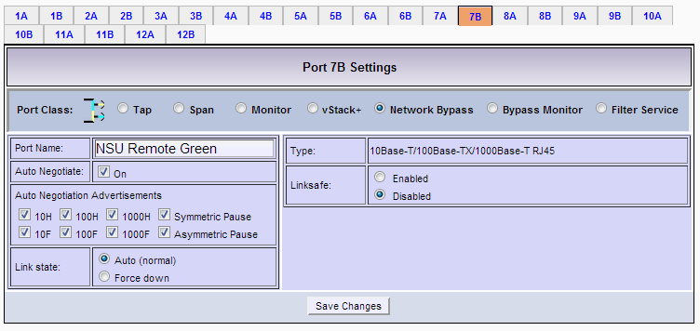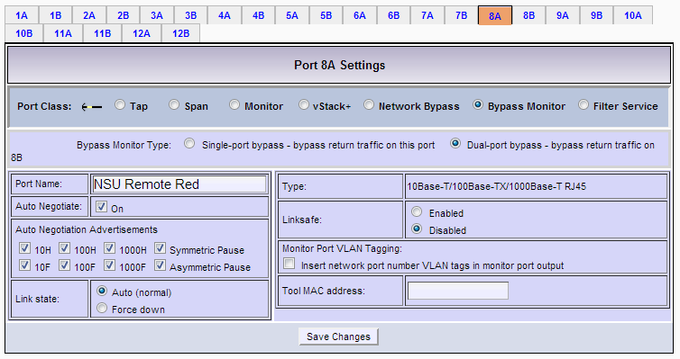
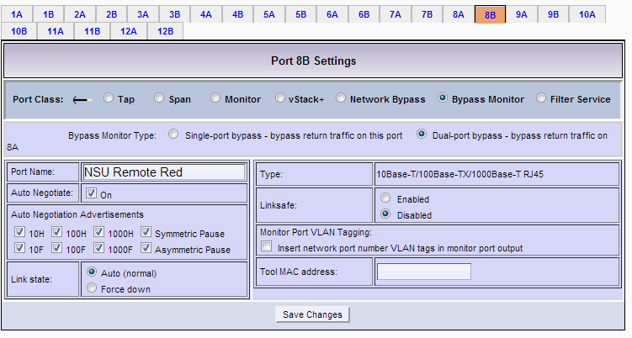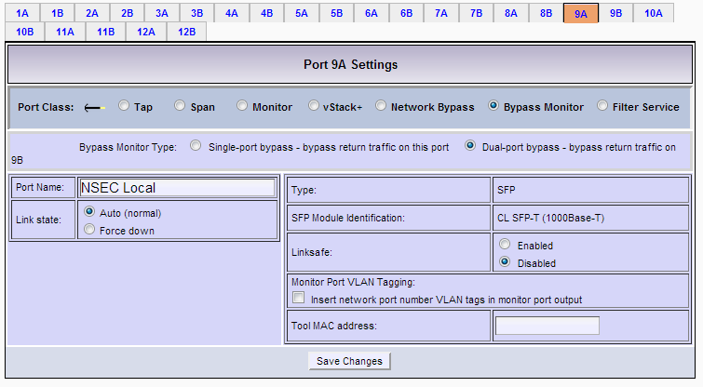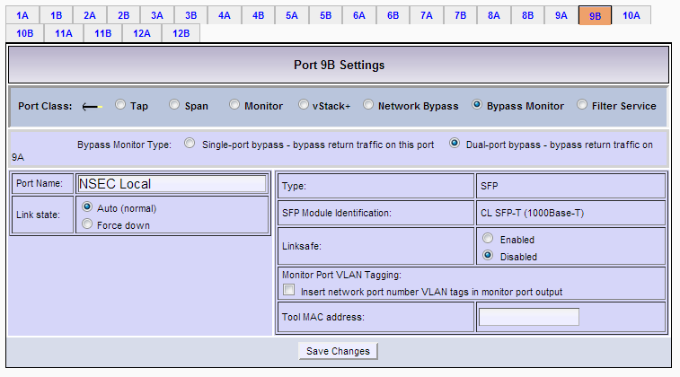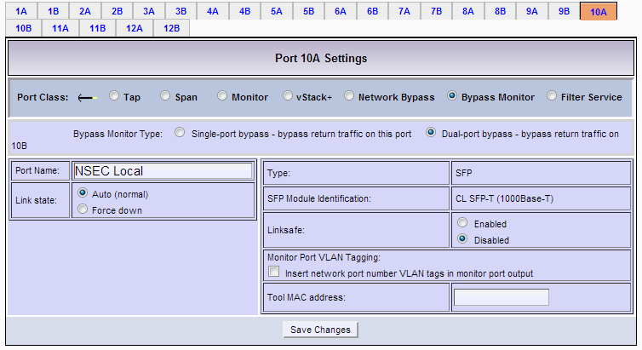
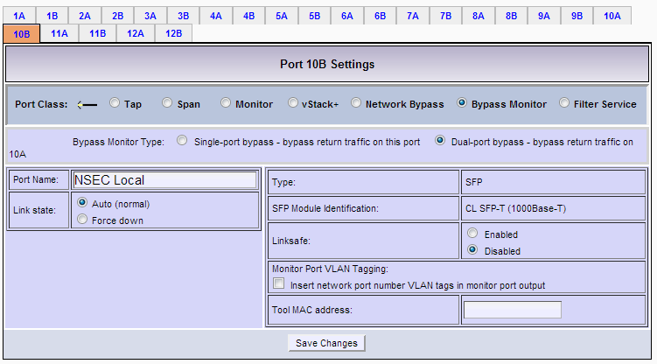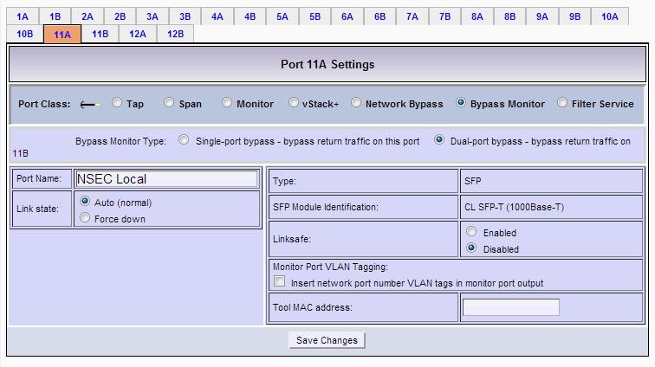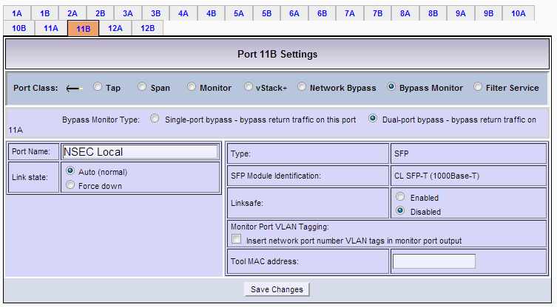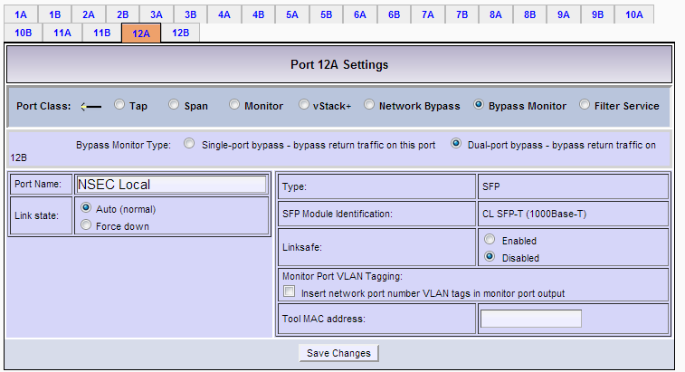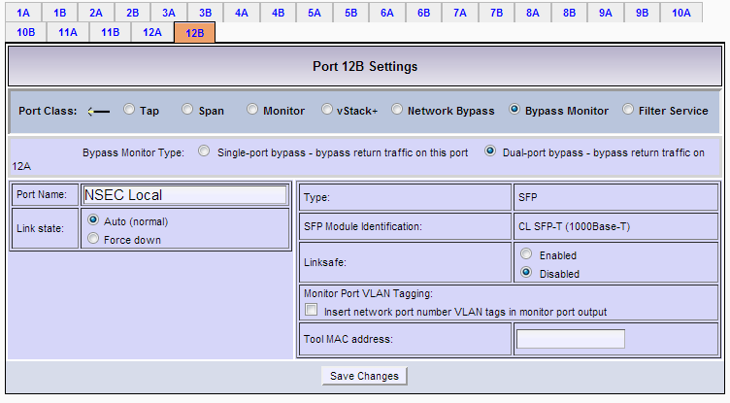

Filtering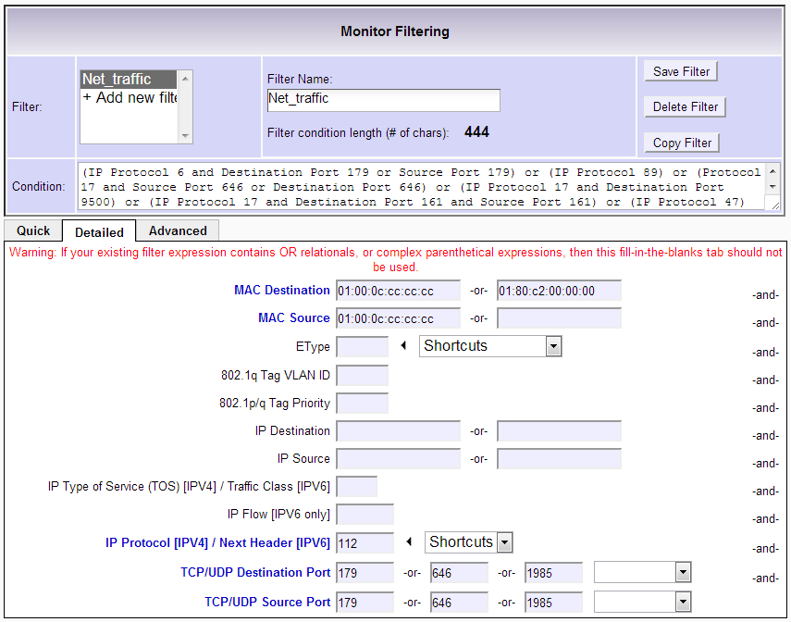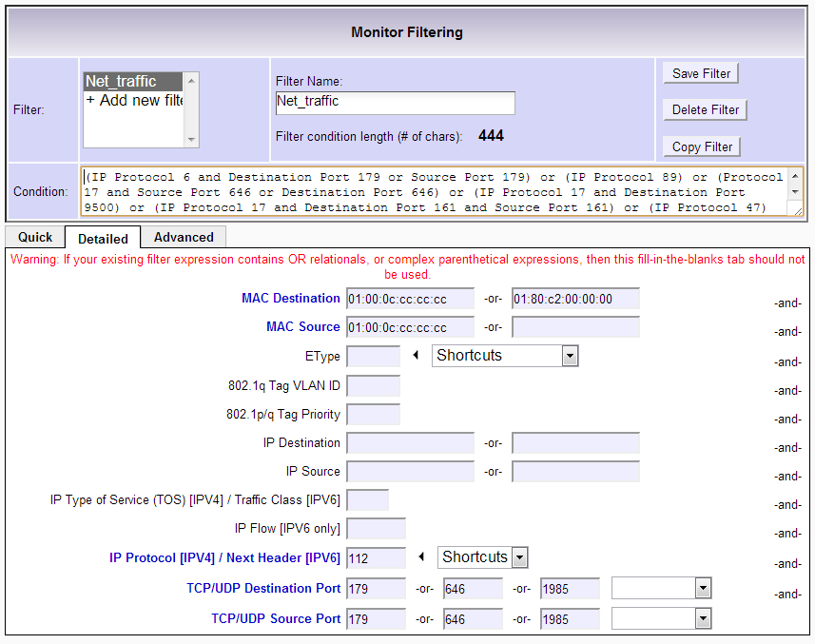

Bypass Monitor Settings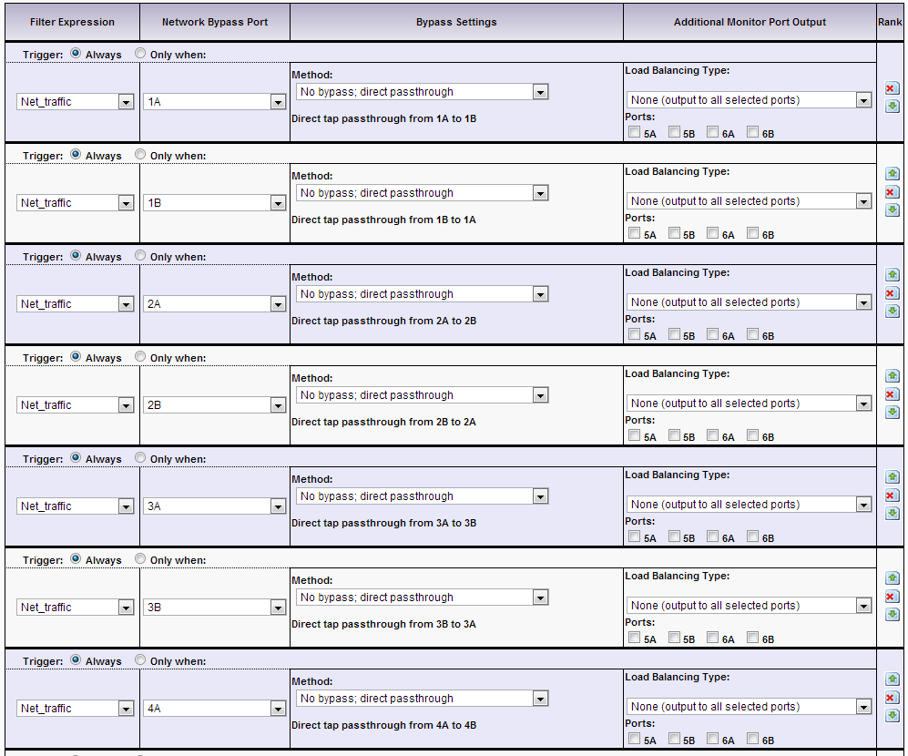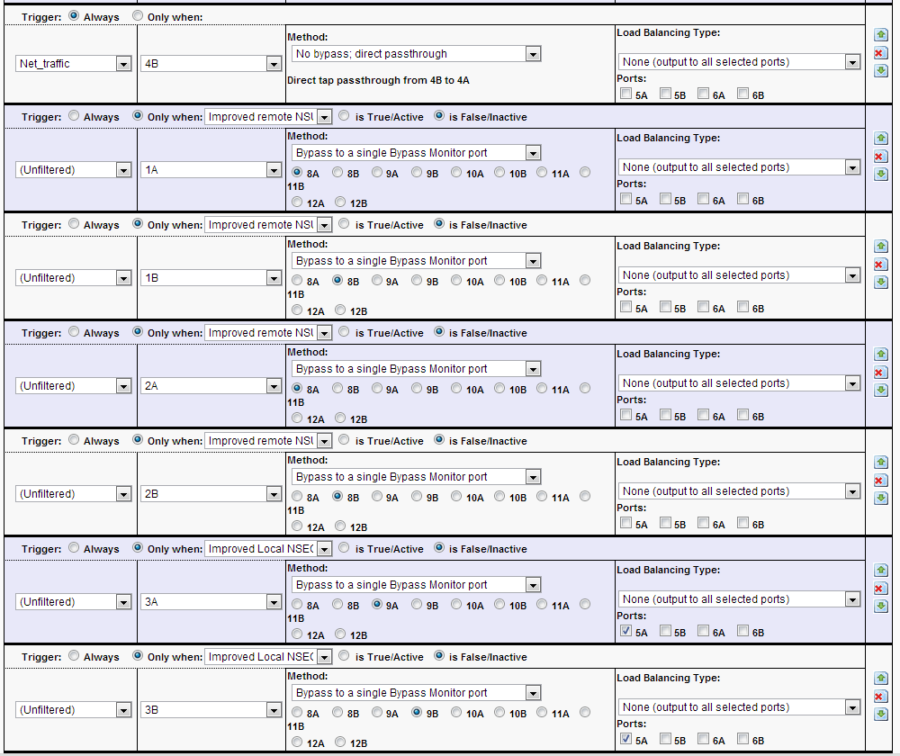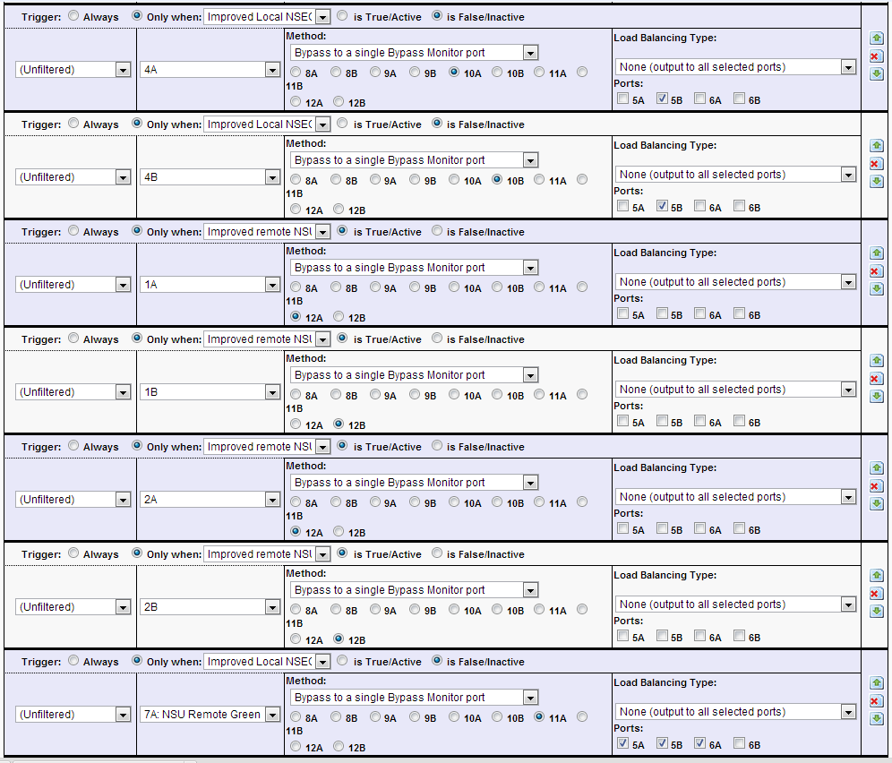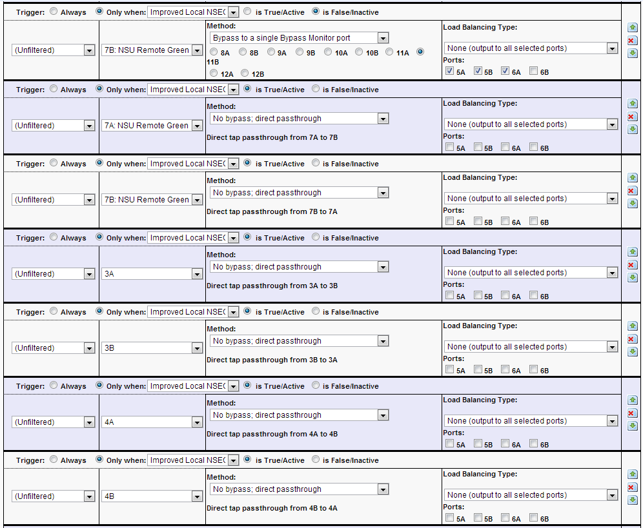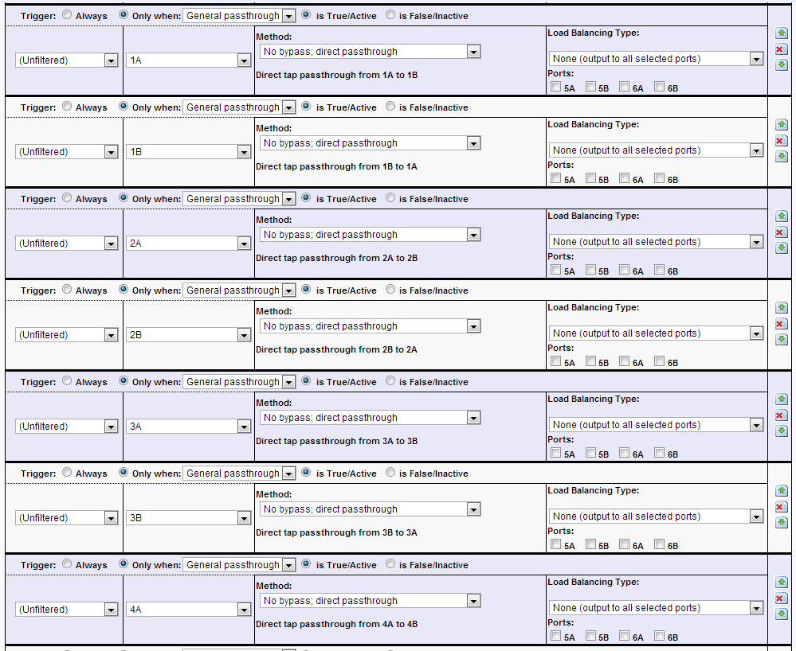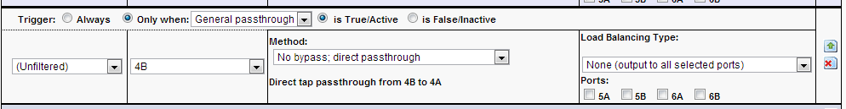

Triggers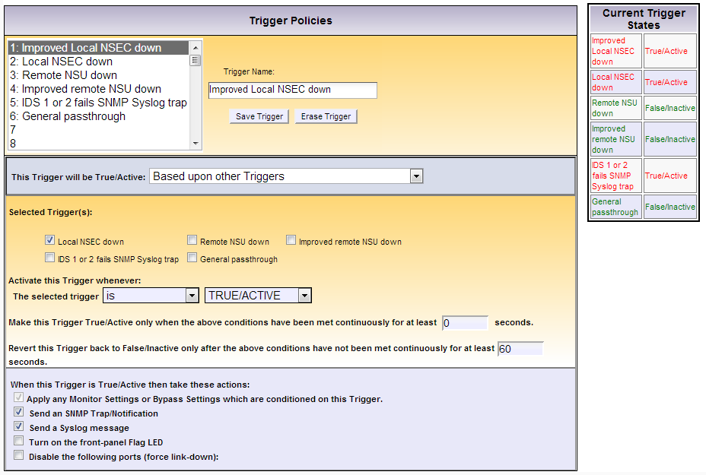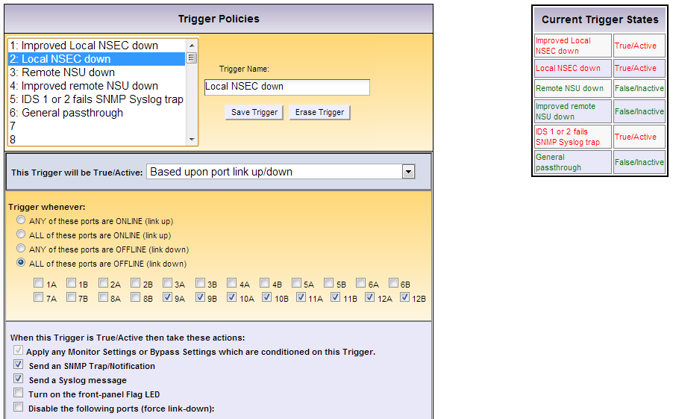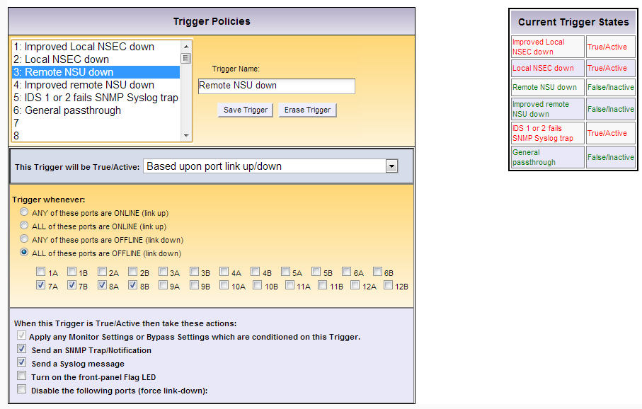
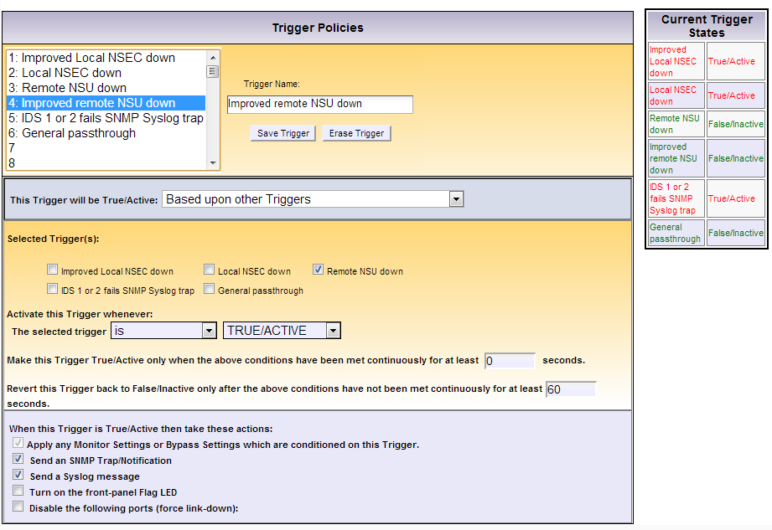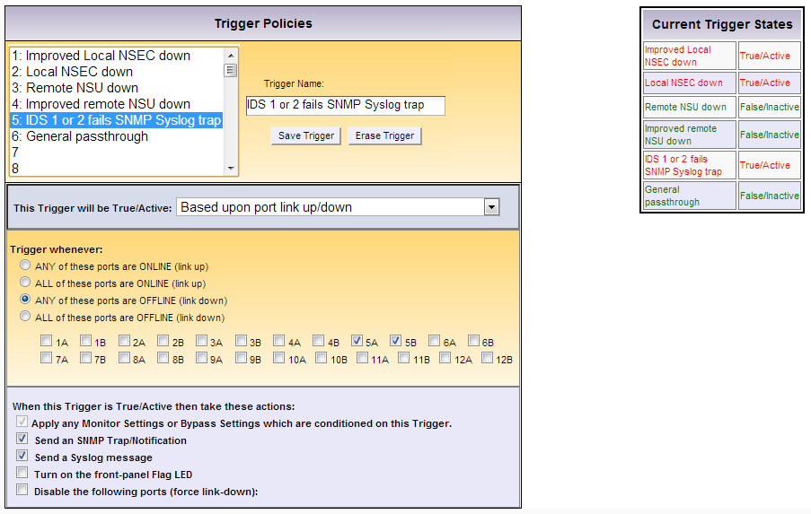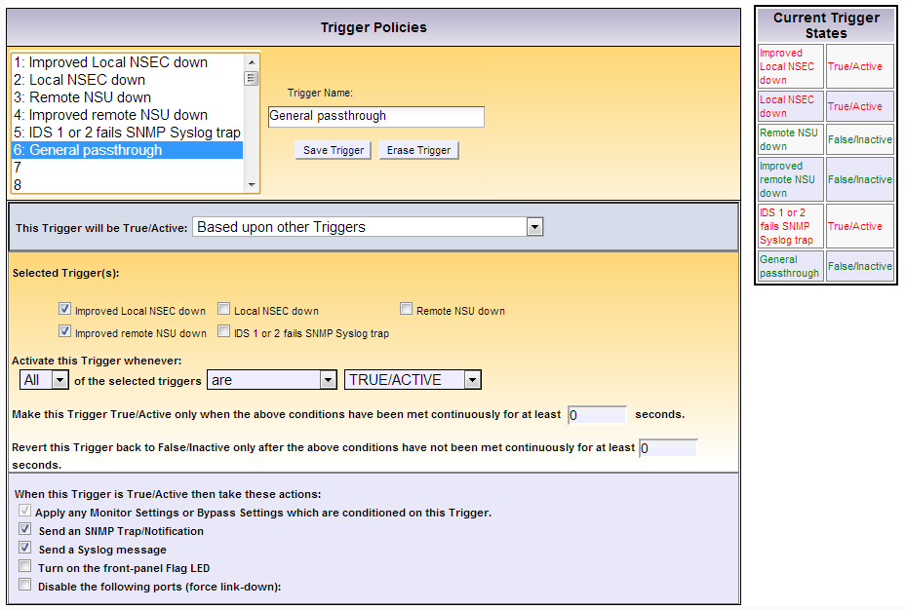

Vodafone NSEC Internet
Port setup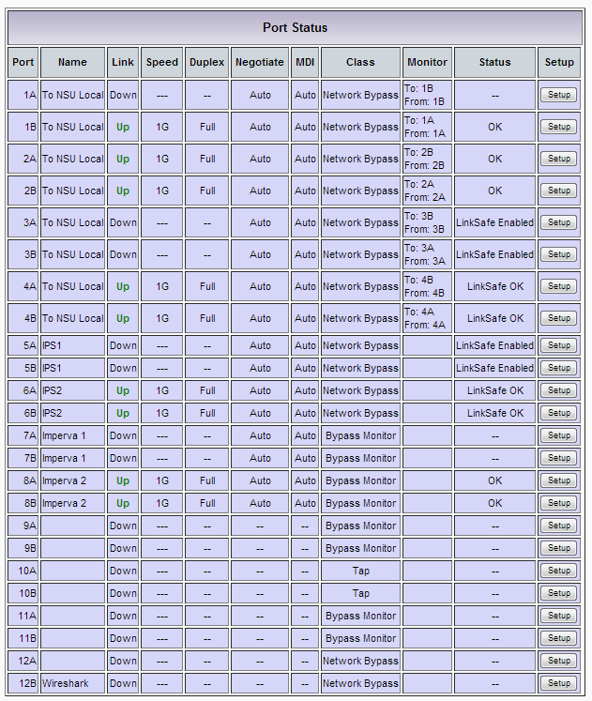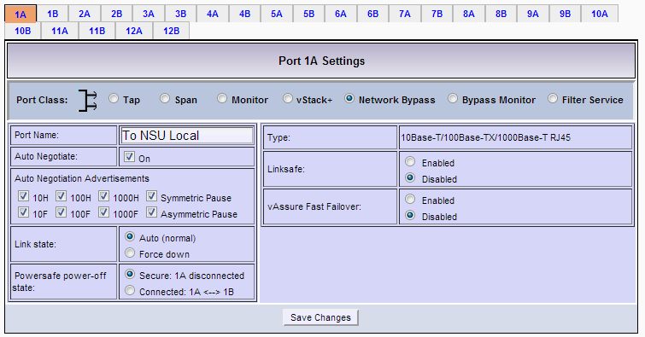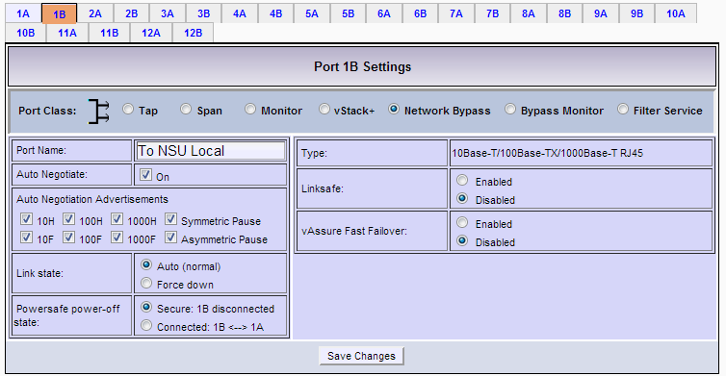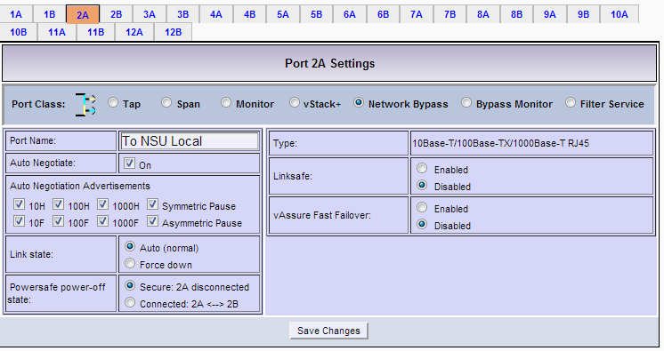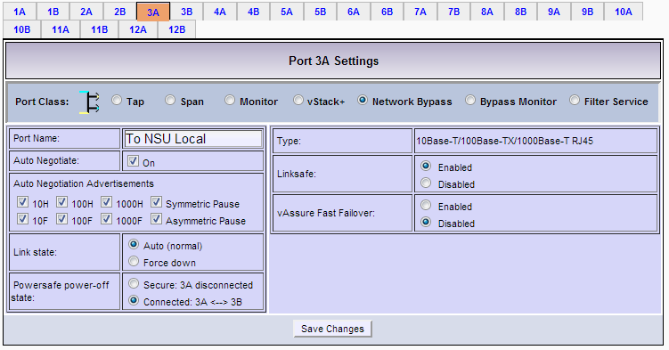
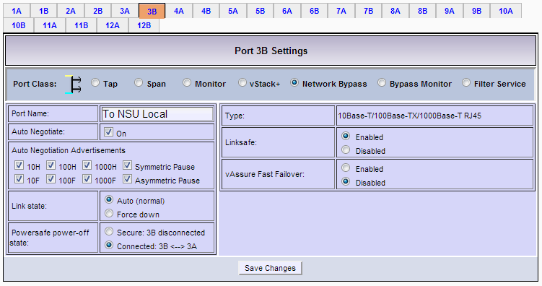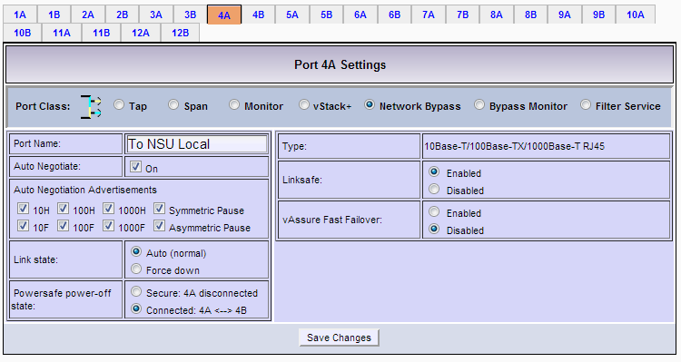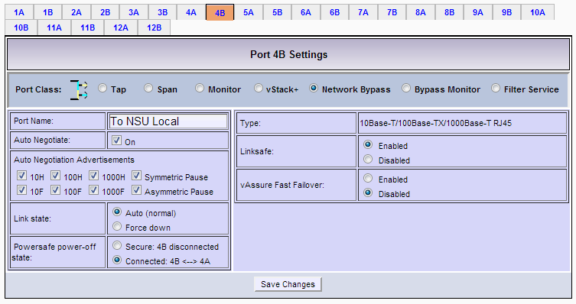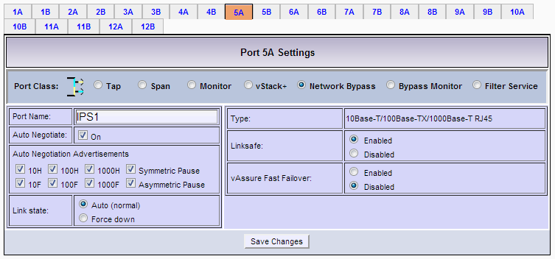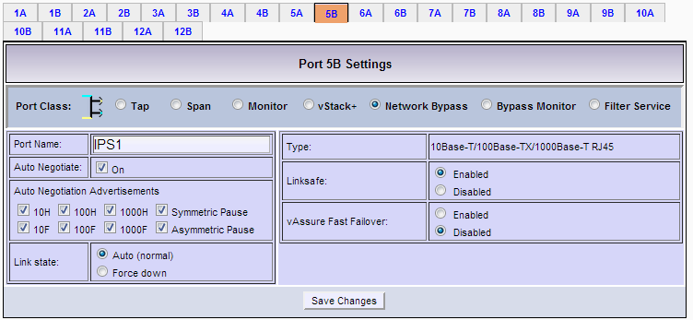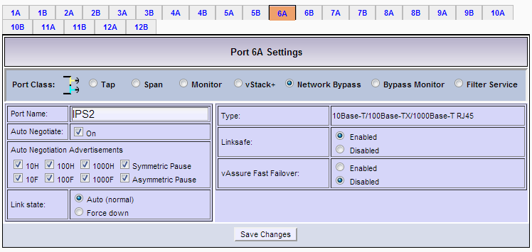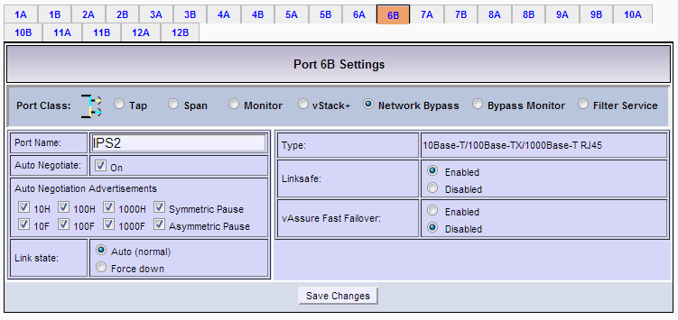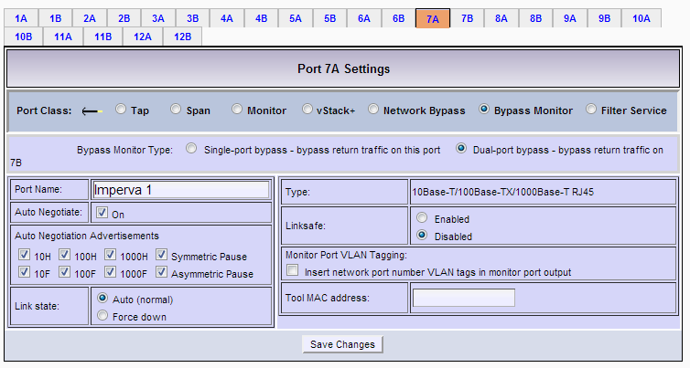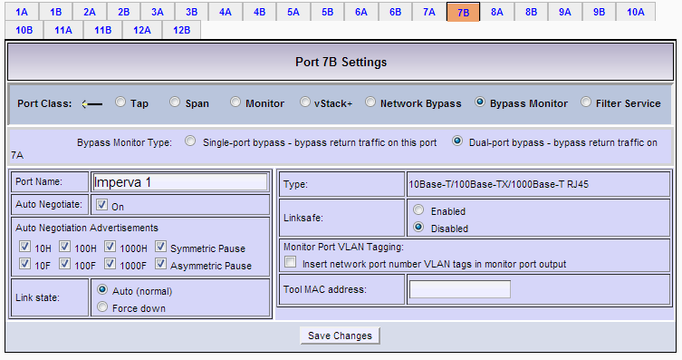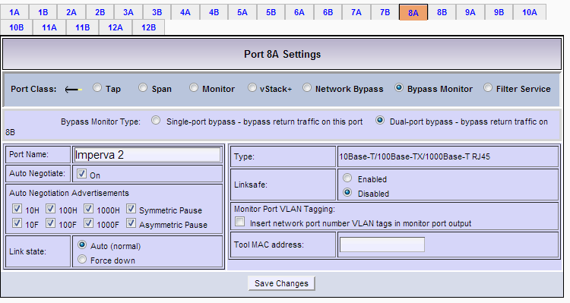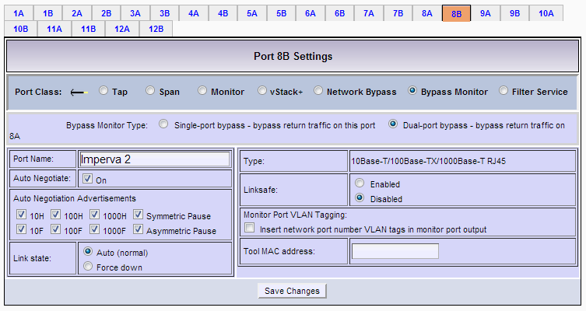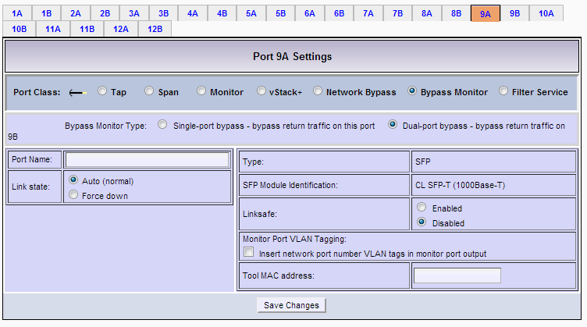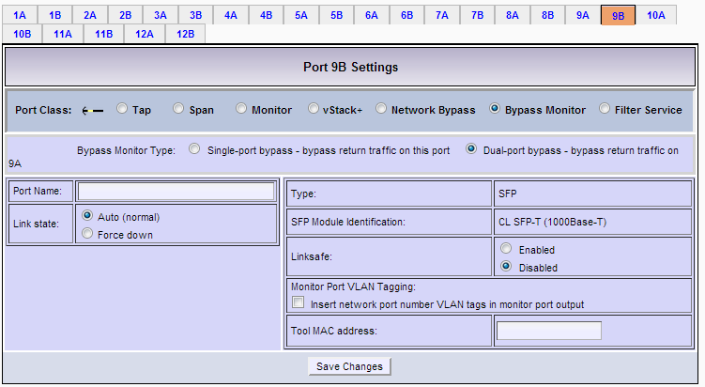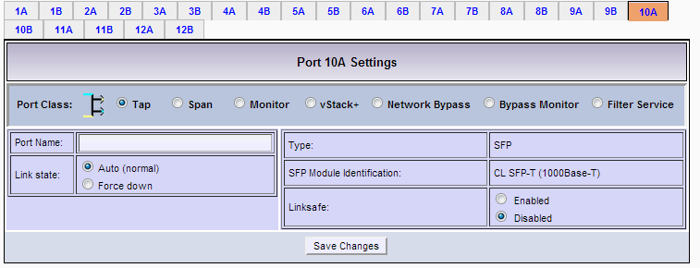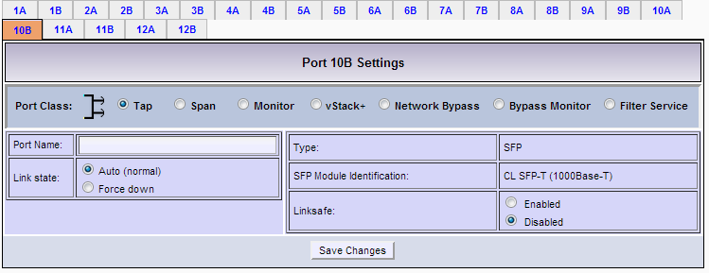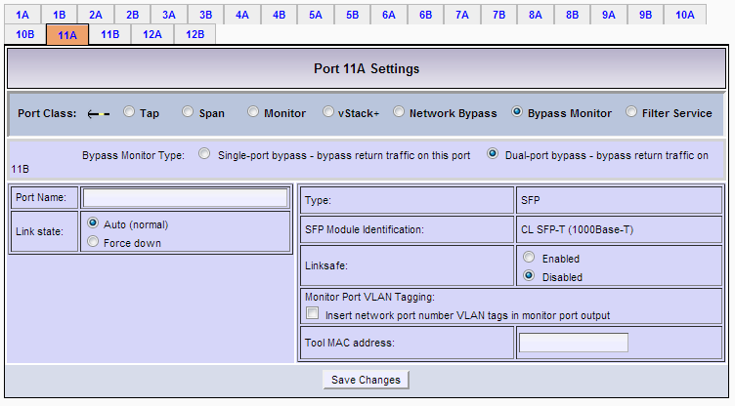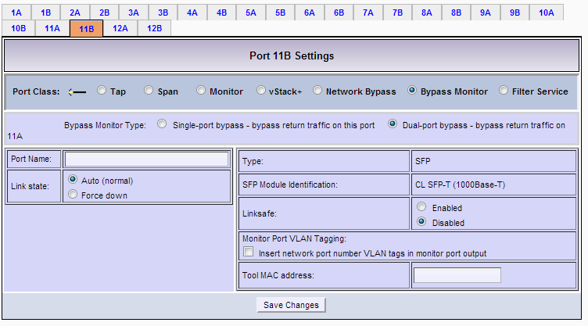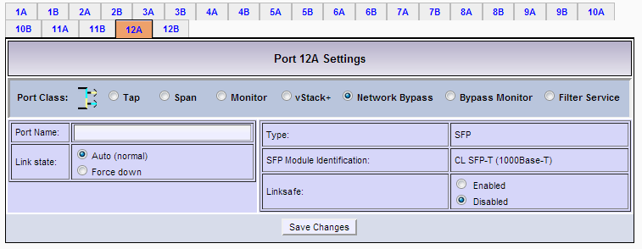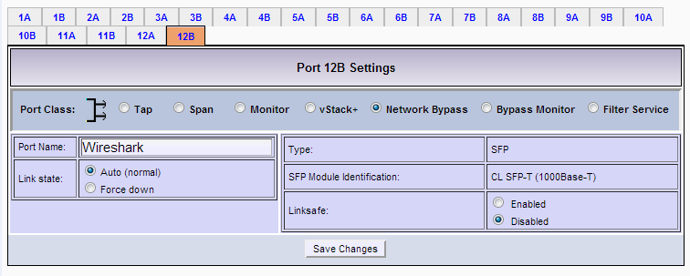

Filtering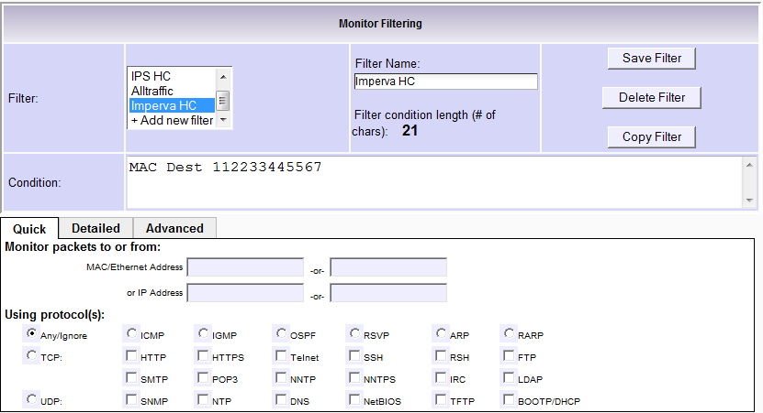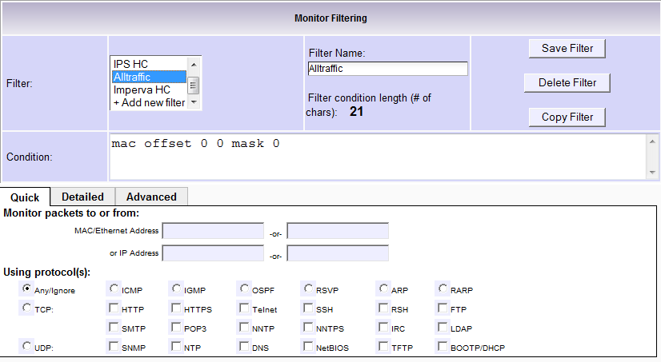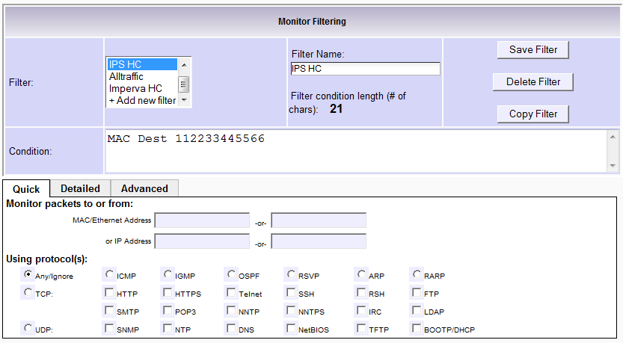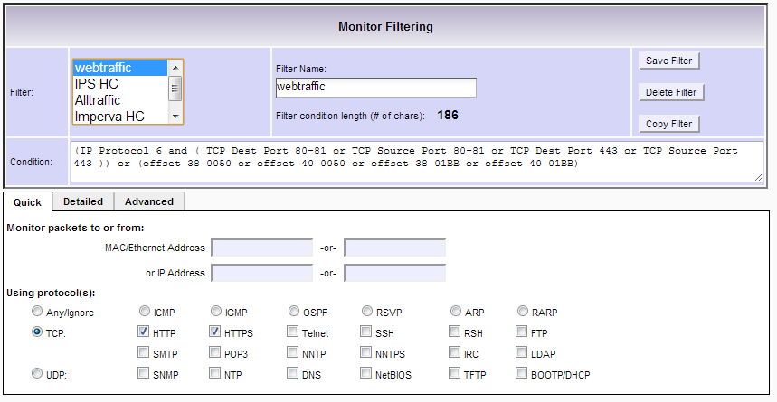

Load Balancing Settings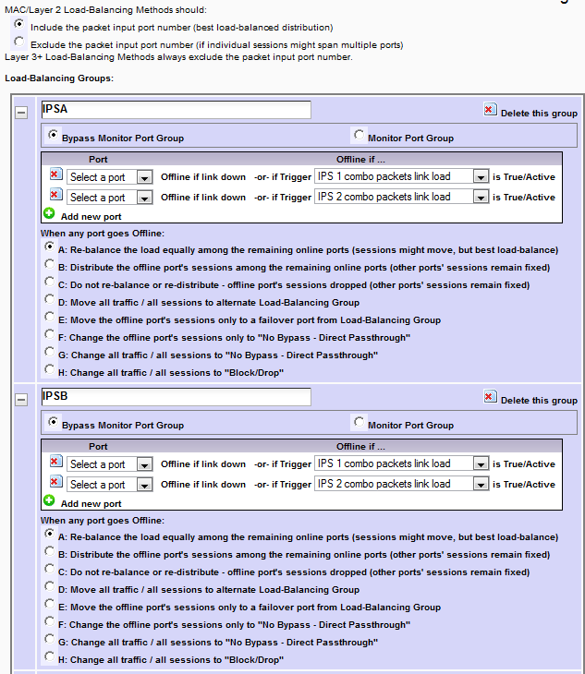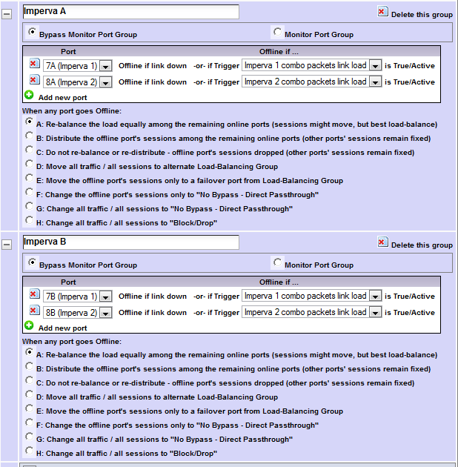

Bypass Monitor Settings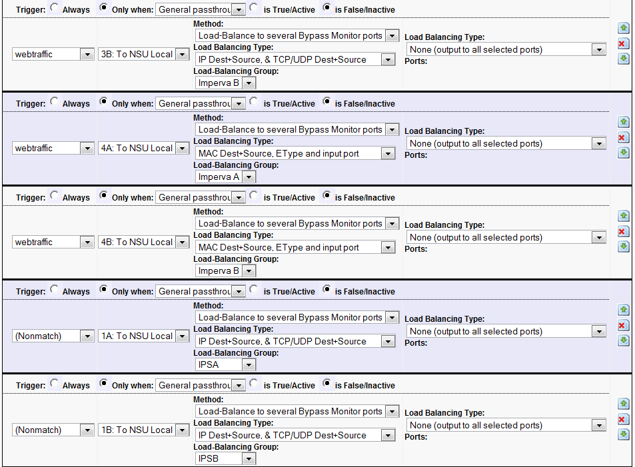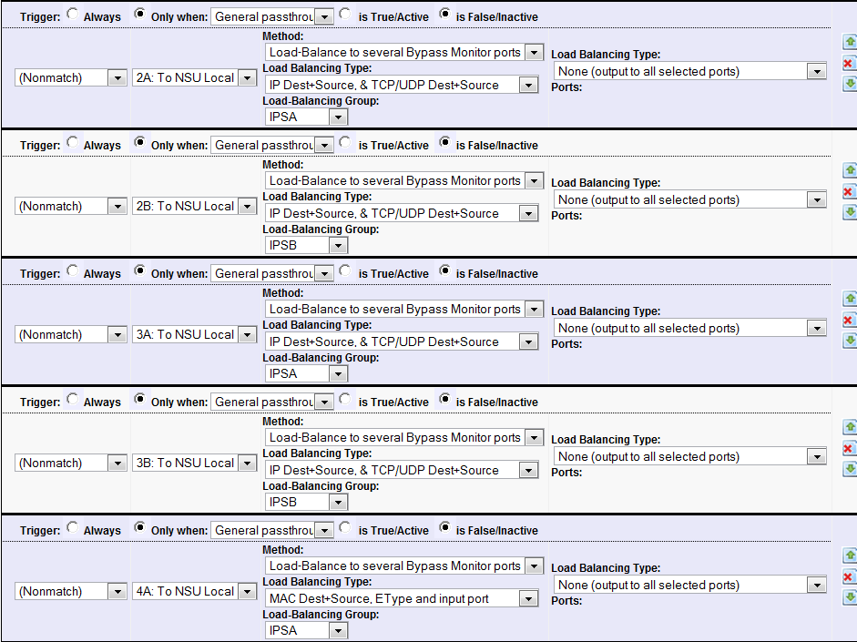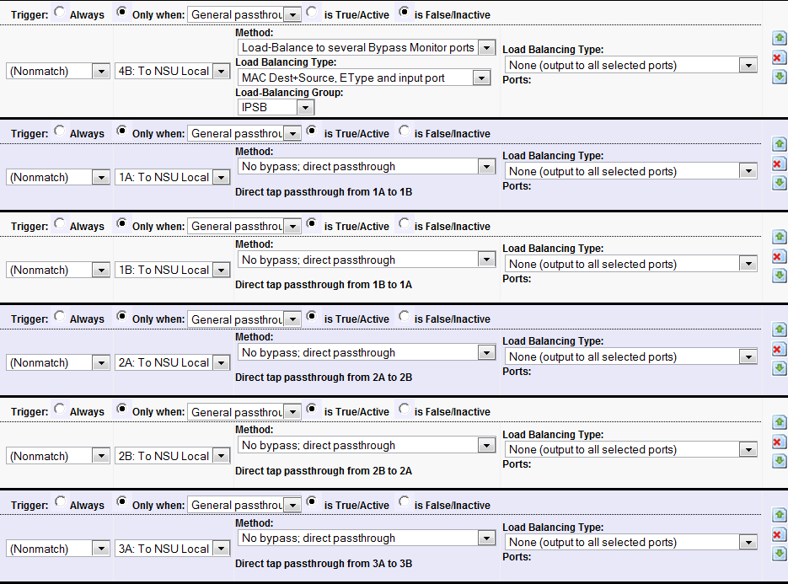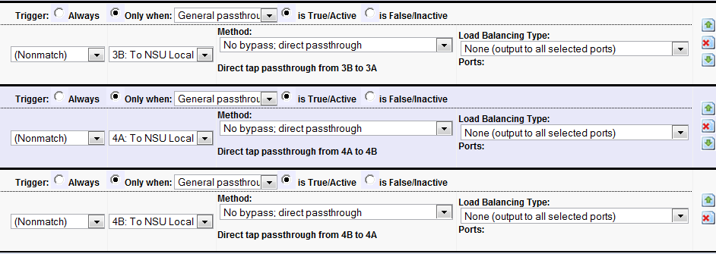
Monitor Settings 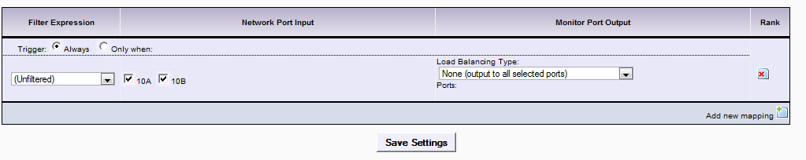

Triggers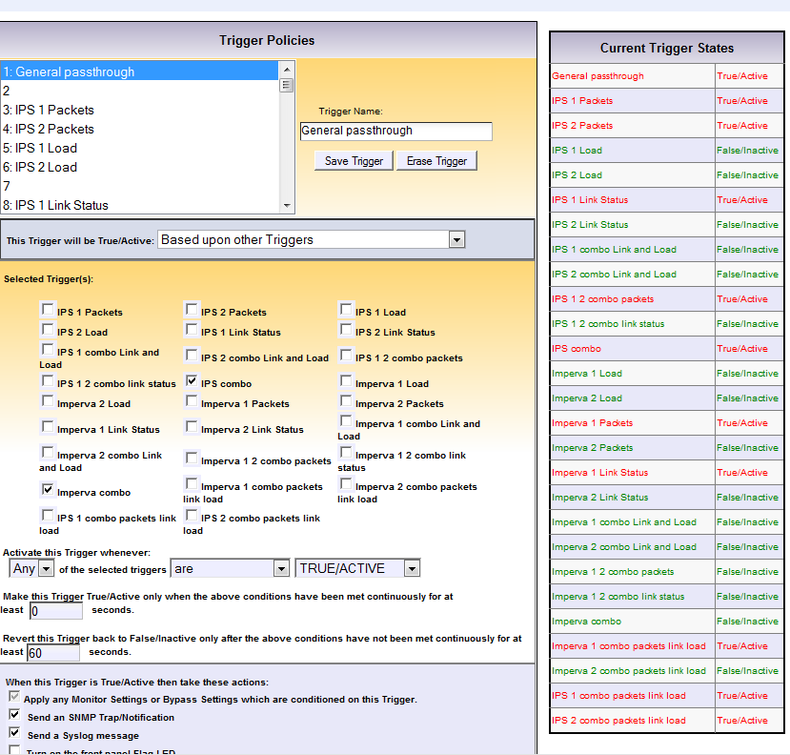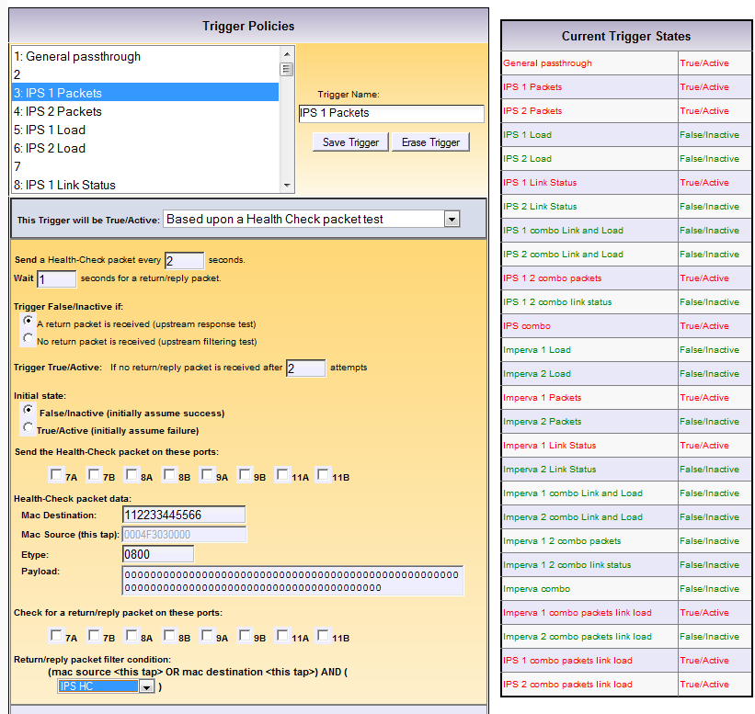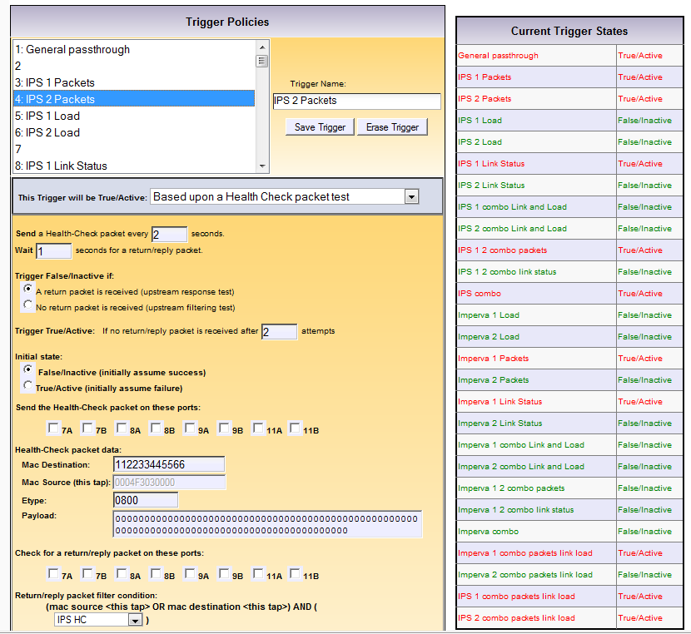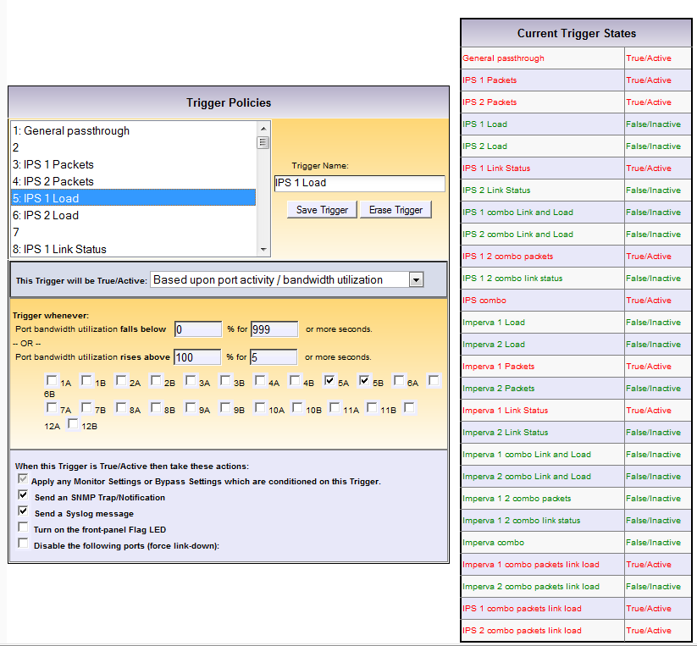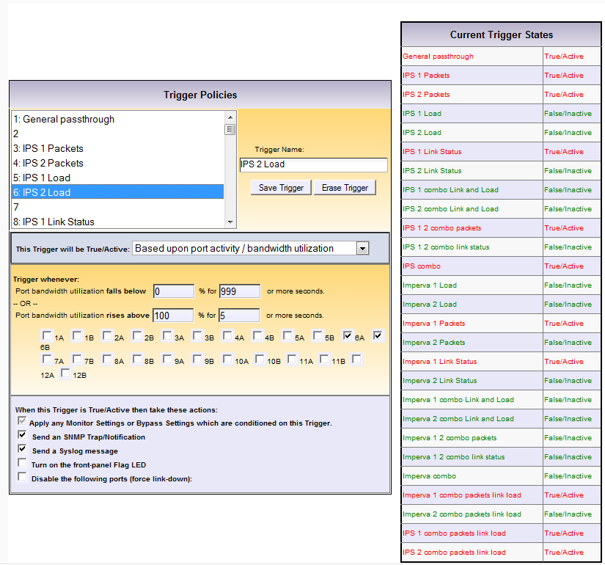
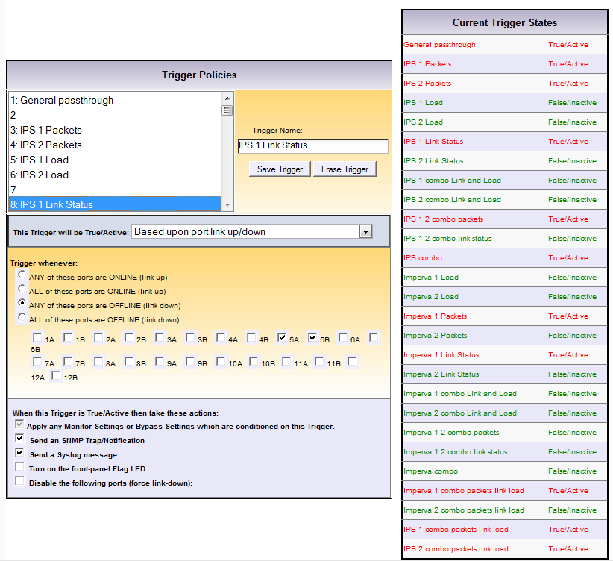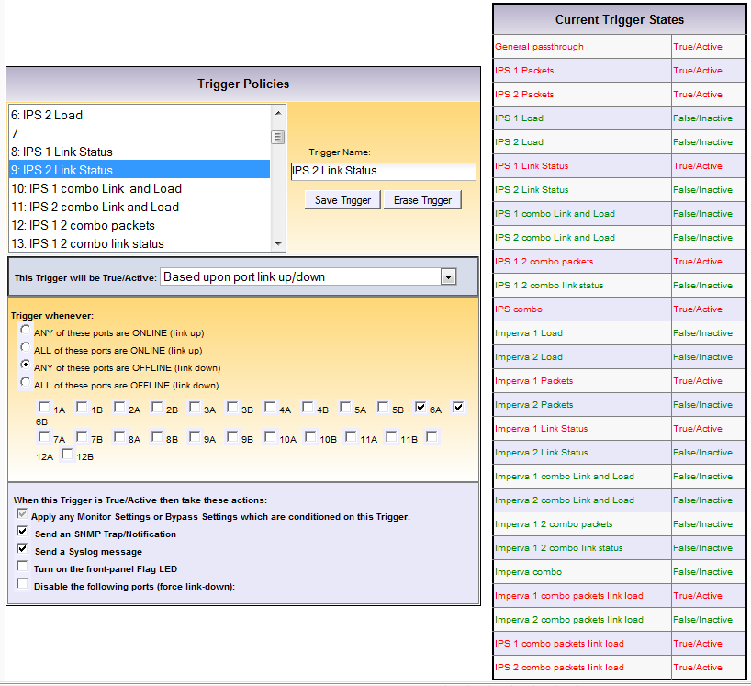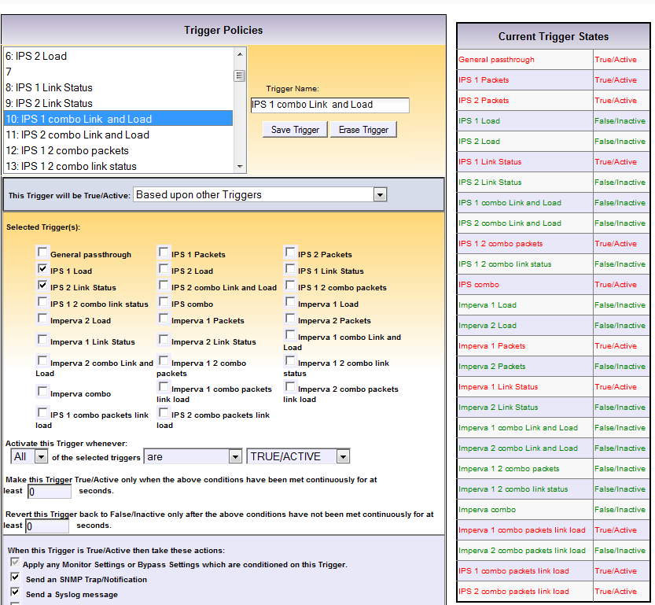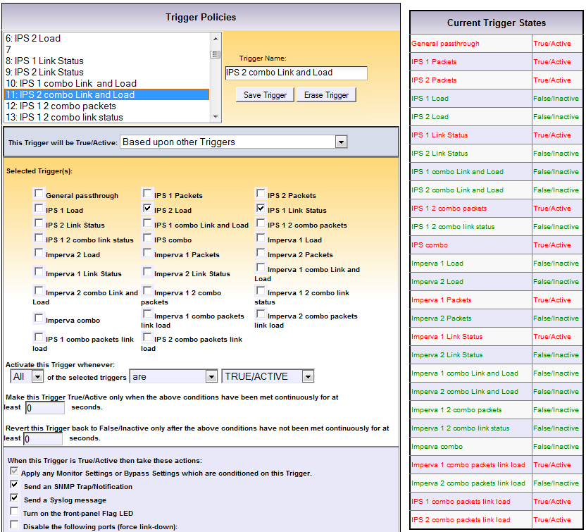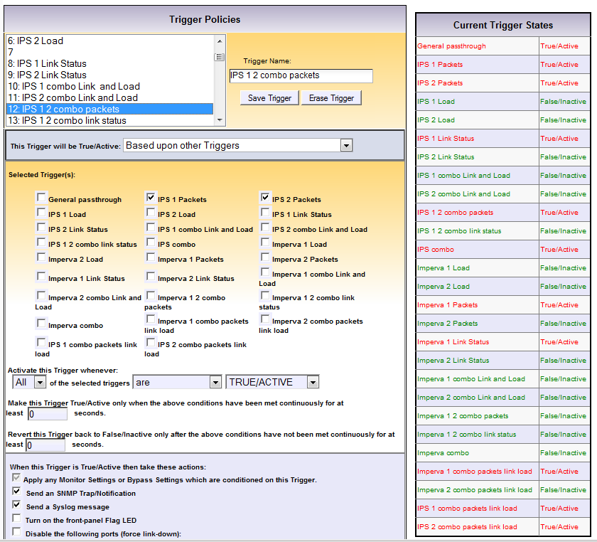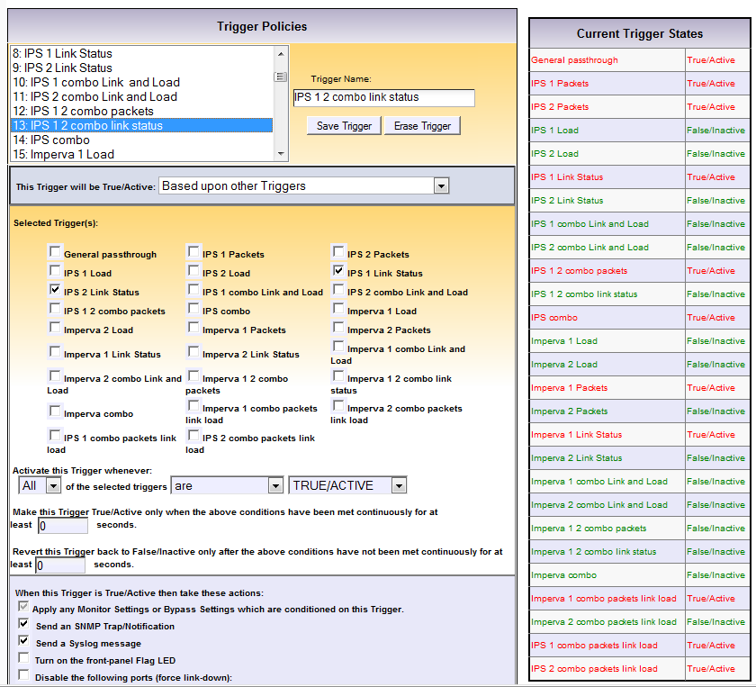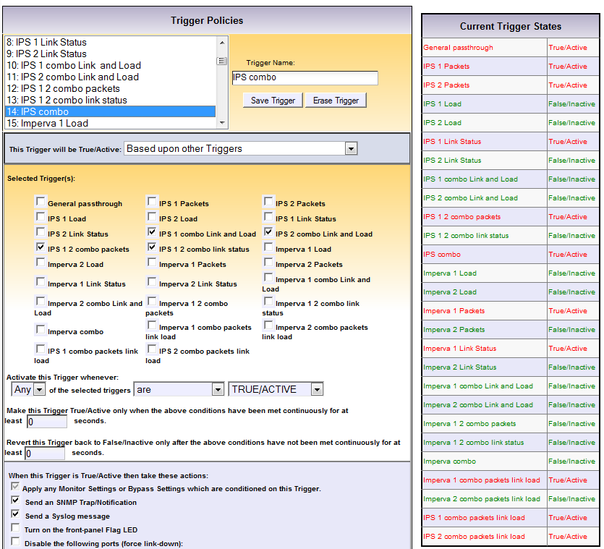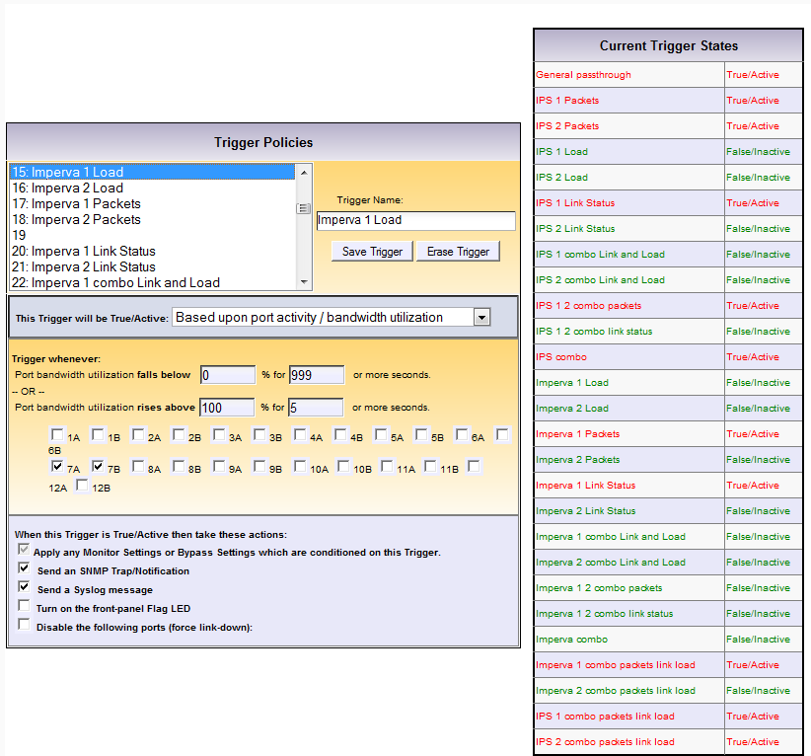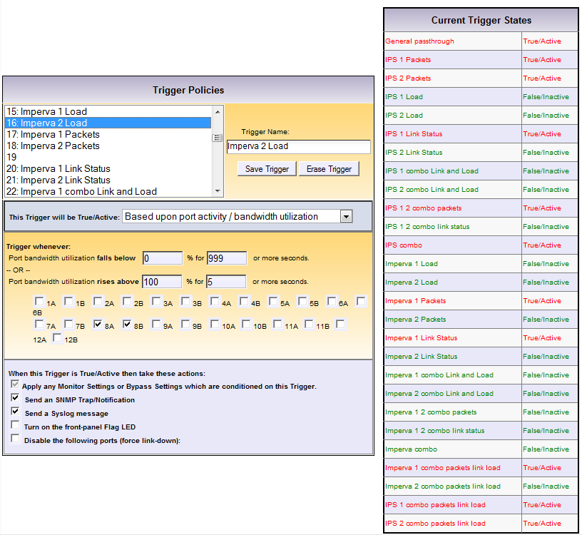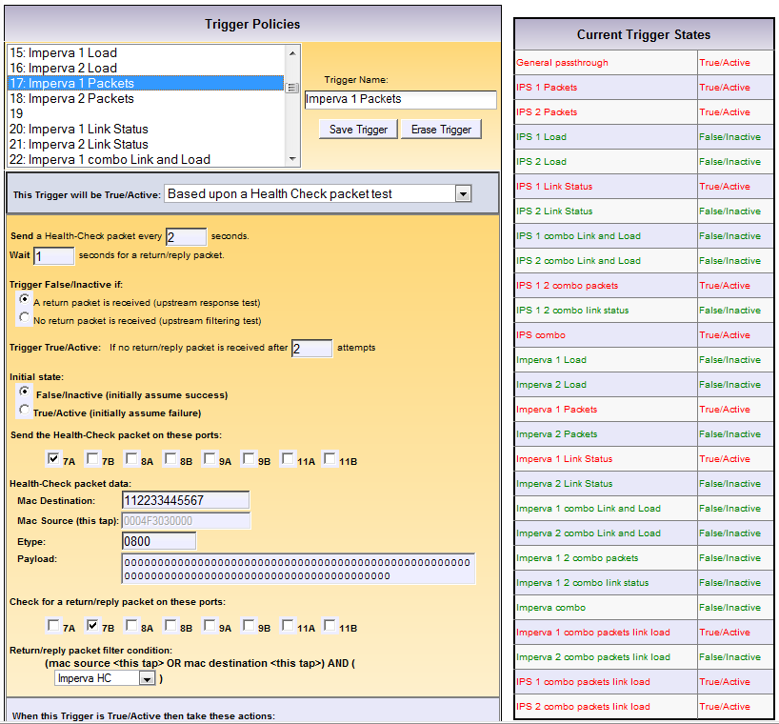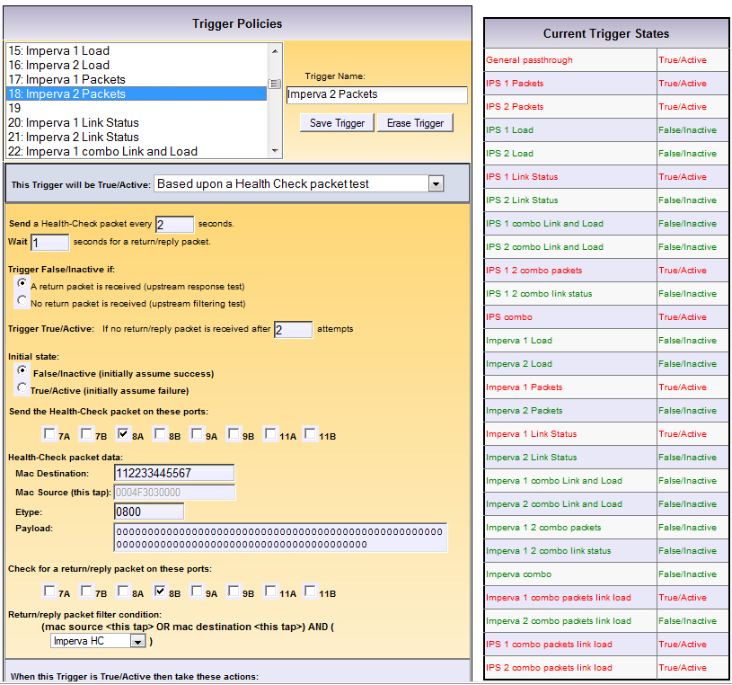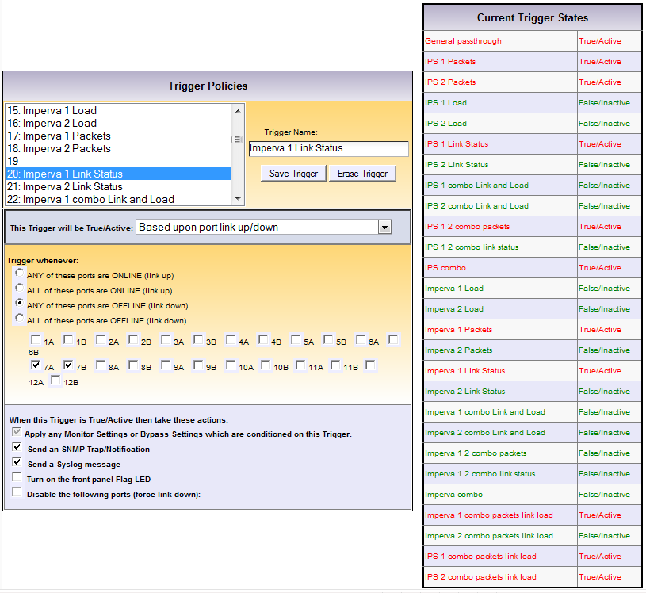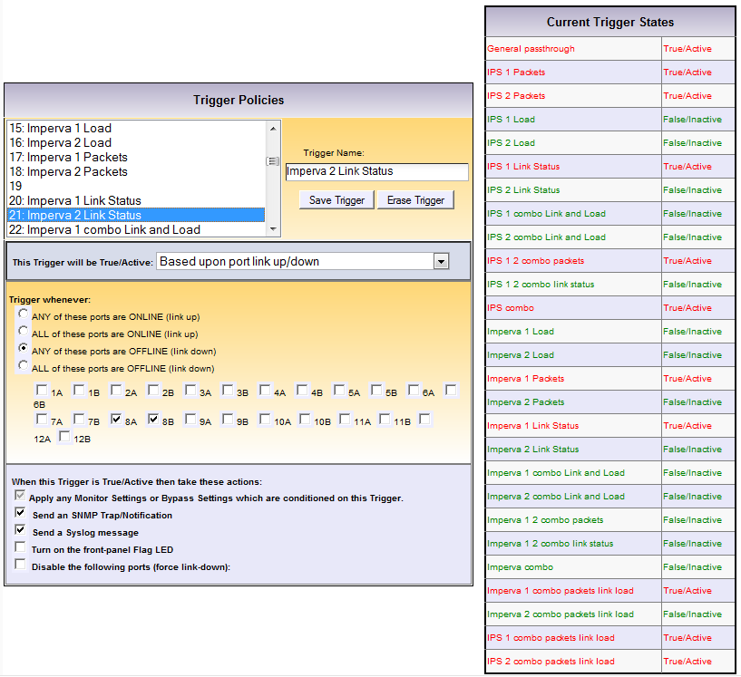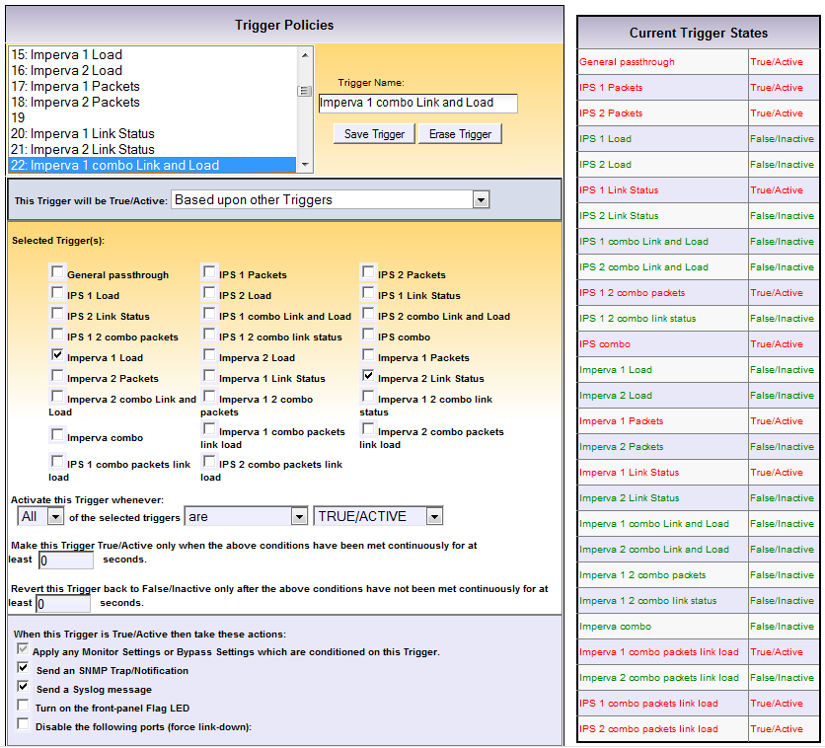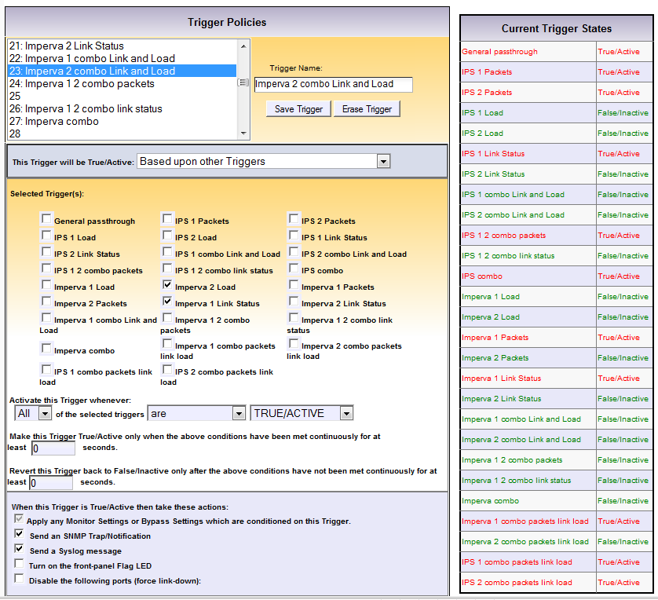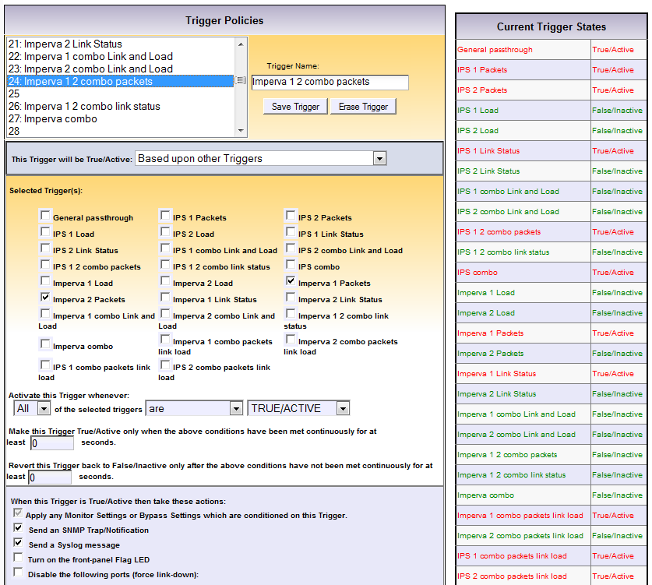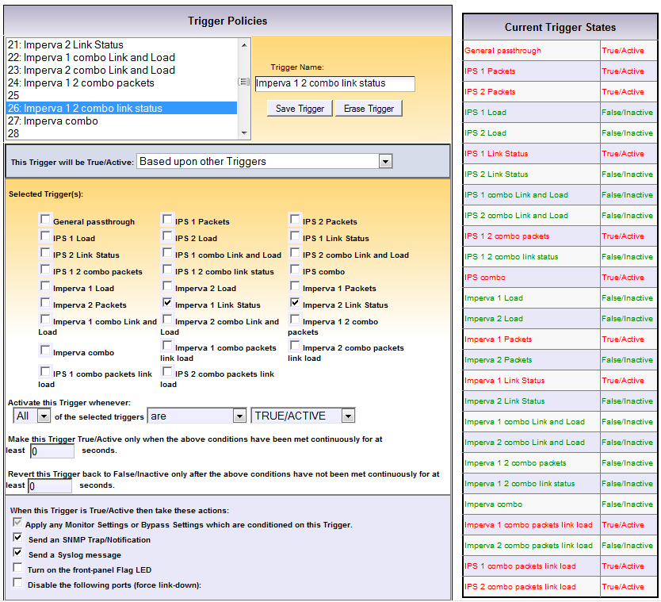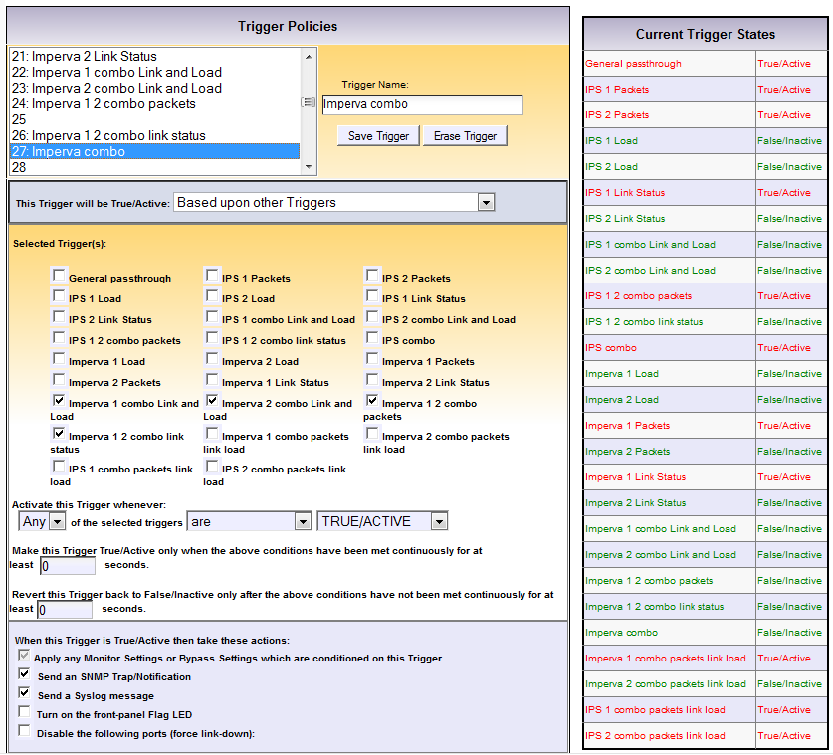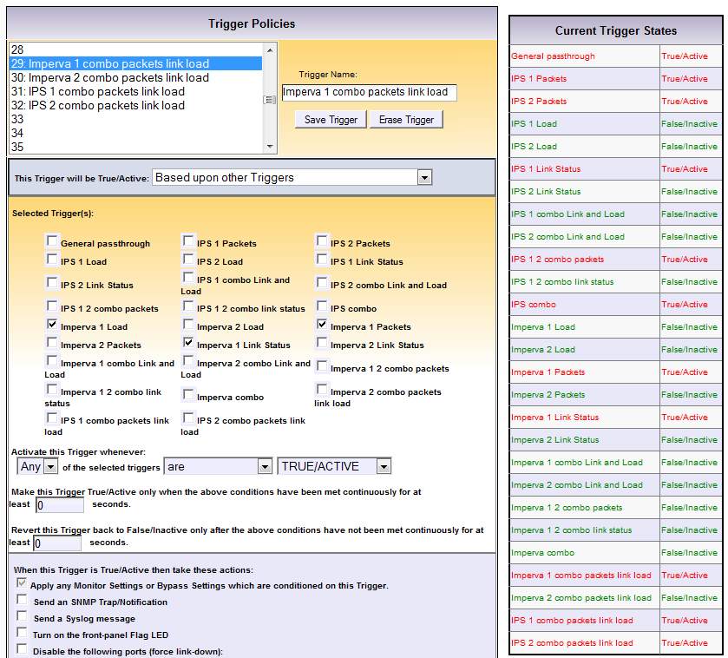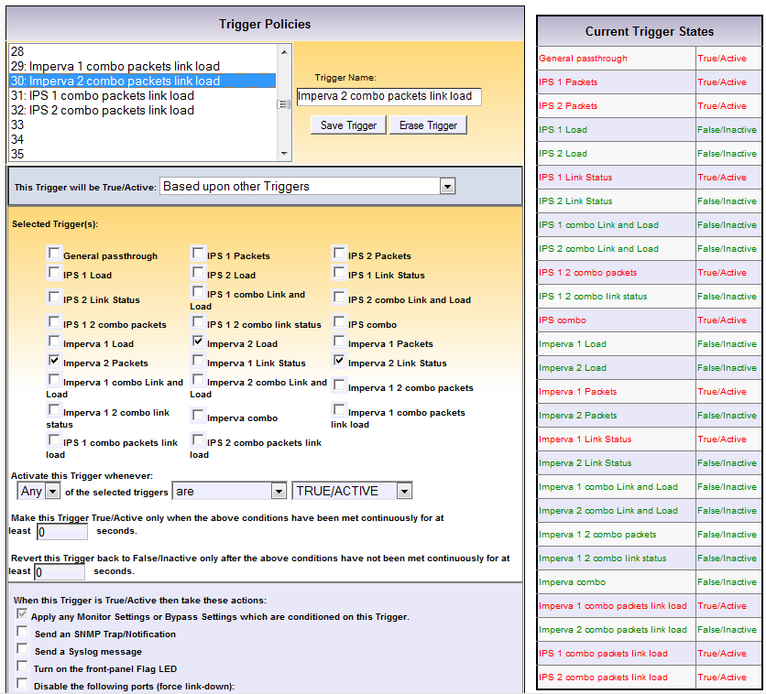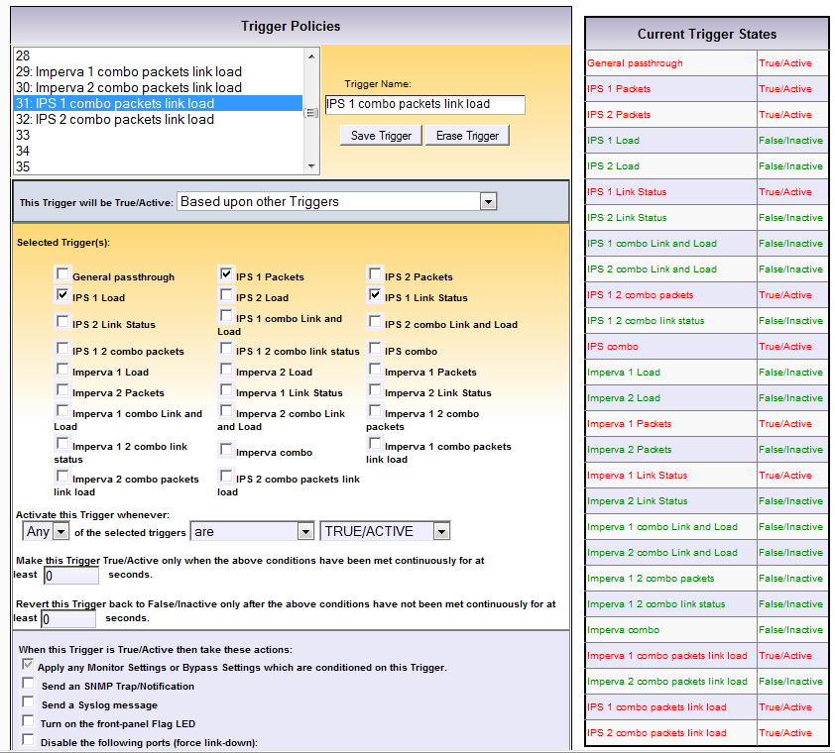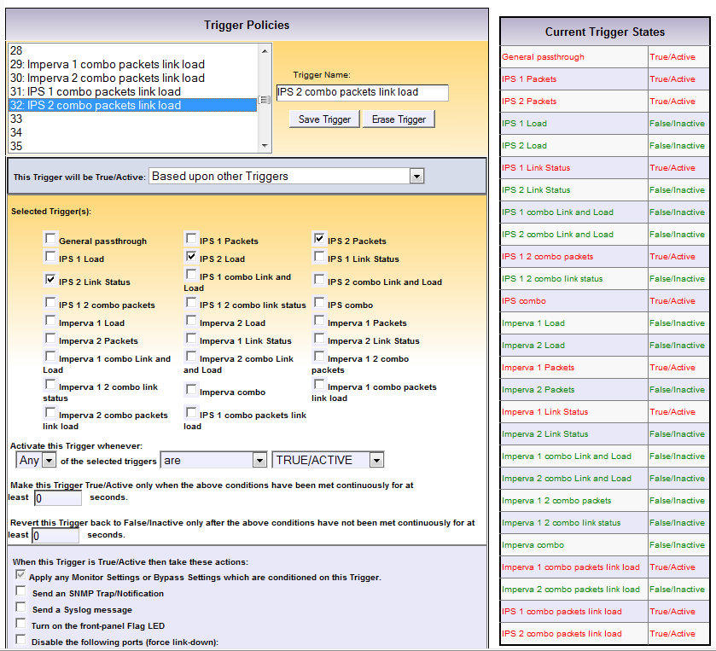

Vodafone NSEC Office Net
Port setup 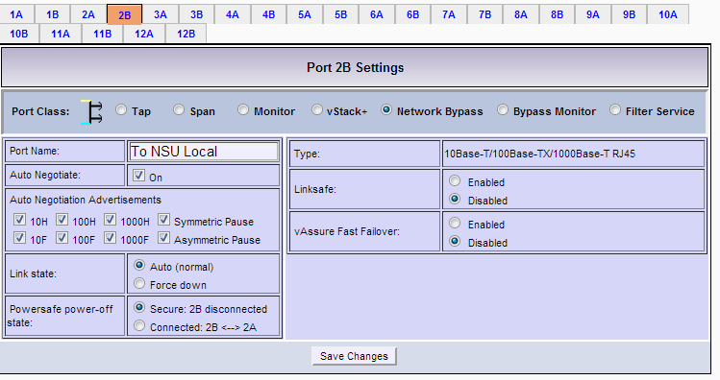

Filtering

Load Balancing Settings

Bypass Monitor Settings
Monitor Settings

Triggers

